Big Data Analytics and Visualization Lab C23031



## Deccan Education Society’s

**NAVINCHANDRA MEHTA INSTITUTE OFTECHNOLOGY AND DEVELOPMENT**

**“Big Data Analytics and Visualization” SUBMITTED BY**

**Siddhesh Dhumak**

**2023-2025**

**Submitted to University of Mumbai**

**In partial fulfilment of the requirements for qualifying MCA SEM [3] Examination in the Subject of**

**“Big Data Analytics and Visualization”**

Big Data Analytics and Visualization Lab C23031

**Deccan Education Society’s**

Navinhandra Mehta Institute of Technology and Development

C E R T I F I C A T E

This is to certify that **Mr.Siddhesh Rajesh Dhumak** of M.C.A. Semester

III with **Roll No. C23031** has completed **Big Data Analytics and Visualization** Practical under my supervision in this college during the year 2023-2025.

***REMARKS:***

**Practical In-Charge Associate Director (NMITD)**

Big Data Analytics and Visualization Lab C23031

**INDEX**

|  |  |  |
| --- | --- | --- |
| **Practical No.** | **Problem Statement** | **Date** |
| 1 | HDFS: List of Commands (mkdir, touchz, copy from local/put, copy to local/get, move from local, cp, rmr, du, dus, stat) |  |
| 2 | Map Reduce:   1. Write a program in Map Reduce for Word Count operation. 2. Write a program in Map Reduce for Union operation. 3. Write a program in Map Reduce for Intersection operation. 4. Write a program in Map Reduce for Grouping and Aggregation. 5. Write a program in Map Reduce for Matrix Multiplication. |  |
| 3 | MongoDB :   1. Installation 2. Sample Database Creation 3. Querythe Sample Database using MongoDB querying commands    1. Create Collection    2. Insert Document    3. Query Document    4. Delete Document    5. Indexing |  |
| 4 | Hive:   1. Hive Data Types 2. Create Database & Table in Hive 3. Hive Partitioning 4. Hive Built-In Operators 5. Hive Built-In Functions 6. Hive Views and Indexes 7. HiveQL: Select Where, Select Order By, Select Group By, Select Joins |  |
| 5 | Pig:   1. Pig Latin Basic 2. Pig Data Types, 3. Download the data 4. Create your Script 5. Save and Execute the Script 6. Pig Operations: Diagnostic Operators, Grouping and Joining, Combining &Splitting, Filtering, Sorting |  |
| 6 | Spark:   1. Downloading Data Set and Processing it Spark 2. Word Count in Apache Spark. |  |
| 7 | Visualization using Tableau:  Tableau: Tool Overview, Importing Data, Analyzing with Charts, Creating Dashboards, working with maps, Telling Stories with tableau. |  |

# Practical 1

**Aim**: Set up and Configuration Hadoop using Cloudera.

**Theory**: HDFS is the primary or major component of the Hadoop ecosystem which is responsible for storing large data sets of structured or unstructured data across various nodes and thereby maintaining the metadatain the form of log files. The File System (FS) shell includes various shell-like commands that directly interactwith the Hadoop Distributed File System (HDFS) as well as other file systems that Hadoop supports,such as Local FS, WebHDFS, S3 FS, and others.

**Hadoop Commands:**

1. mkdir

Command: hdfs dfs -mkdir

Use: Create a directory under Hadoop file system

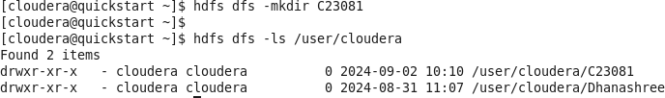

1. touchz

command: hdfs dfs -touchz

Use: Create a file named under Hadoop file system

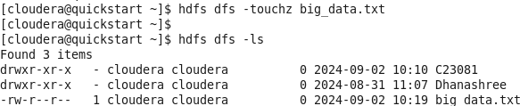

1. copyFromLocal/ put

command: hdfs dfs -copyFromLocal

Use: Copy files from local file system to Hadoop file system



1. copyToLocal/ get

command: hdfs dfs -copyToLoal

use: copy files from Hadoop file system to local file system

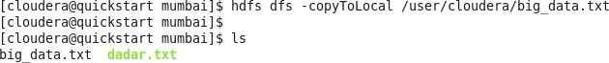

1. cp

command: hdfs dfs -cp

use: copy files from one directory to another directory within the HDFS

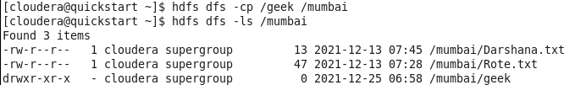

1. rm r

command: hdfs dfs -rm -r

use: removes the file or directory identified by path

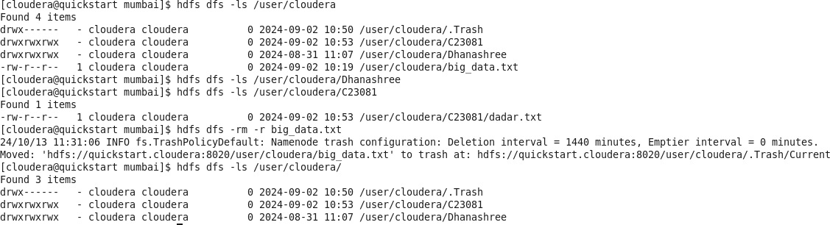

1. Du -s

Command: hdfs dfs –du –s

Use: Prints a summary of disk usage of all files/directories in the path.

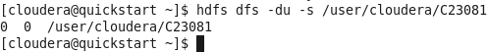

1. Stat

Command: hdfs dfs –stat

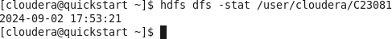Use: Prints information about path.

# Practical-02

**Aim:** Perform MapReduce Algorithm Programs

**Description:** What is MapReduce?

MapReduce is a programming paradigm that enables massive scalability across hundredsor thousands of servers in a Hadoop cluster. As the processing component, MapReduce is the heartof Apache Hadoop. The term "MapReduce" refers to two separate and distinct tasks that Hadoop programs perform.

The first is the map job, which takes a set of data and converts it into another set of data, whereindividual elements are broken down into tuples (key/value pairs). The reduce job takes the output from a map as input and combines those data tuples into a smaller set of tuples. As the sequence of the nameMapReduce implies, the reduce job is always performed after the map job. MapReduce programmingoffers several benefits to help you gain valuable insights from your big data: **Scalability**- Businesses can process petabytes of data stored in the Hadoop Distributed FileSystem (HDFS).

**Flexibility**- Hadoop enables easier access to multiple sources of data and multiple types of data.

**Speed**- With parallel processing and minimal data movement, Hadoop offers fastprocessing of massive amounts of data.

**Simple**- Developers can write code in a choice of languages, including Java, C++ and Python. Inourcase we’ll use Java as programming language and pyspark for some other operations. Stay tuned.

**Program 1:** MapReduce for Average Word Count In eclipse create 3 java classes and add external jar inside filesystem>usr>lib>Hadoop and client>

Codes:

WordCountDriver.java

import org.apache.hadoop.conf.Configuration; import org.apache.hadoop.fs.Path; import org.apache.hadoop.io.IntWritable; import org.apache.hadoop.io.Text;

import org.apache.hadoop.mapreduce.lib.output.FileOutputFormat; import org.apache.hadoop.mapreduce.Job:

import org.apache.hadoop.mapreduce.lib.input.FileInputFormat;

publicclass WordCountDriver {

public static void main(String[] args) throws Exception

{Job j1= Job.getInstance(newConfiguration()); j1.setJarByClass(WordCountDriver.class); j1.setJobName("Average Word Count");

FileInputFormat.addInputPath(j1, new Path(args[0]));FileOutputFormat.setOutputPath(j1, new Path(args[1])); j1.setMapperClass(WordCountMapper.class); j1.setReducerClass(WordCountReducer.class); j1.setOutputKeyClass(Text.class); j1.setOutputValueClass(IntWritable.class); System.exit(j1.waitForCompletion(true)

? 0 : 1);

}

}

WordCountMapper.java

import java.io.IOException; import java.util.StringTokenizer;

import org.apache.hadoop.io.IntWritable; import org.apache.hadoop.io.LongWritable; importorg.apache.hadoop.io.Text;

import org.apache.hadoop.mapreduce.Mapper;

public class WordCountMapper extends Mapper<LongWritable, Text, Text, IntWritable> { private final static IntWritable one = new IntWritable(1);

private Text word = new Text(); @Override

protected void map(LongWritable key, Text value,Mapper<LongWritable, Text, Text, IntWritable>.Context context) throwsIOException, InterruptedException {

String line = value.toString();

StringTokenizer itr = new StringTokenizer(line); while(itr.hasMoreTokens()){ word.set(itr.n extToken()); context.write(word, one);

}

}

}

WordCountReducer.java import java.io.IOException;

import org.apache.hadoop.io.IntWritable; import org.apache.hadoop.io.Text;

import org.apache.hadoop.mapreduce.Reducer;

public class WordCountReducer extends Reducer<Text, IntWritable, Text, IntWritable>

{ @Override

protected void reduce(Text key, Iterable<IntWritable> values, Reducer<Text, IntWritable, Text, IntWritable>.Context context) throwsIOException, InterruptedException {

int sum = 0;

for(IntWritable value:values){ sum+=value.get();

}

context.write(key, new IntWritable(sum));

}

}

Output:

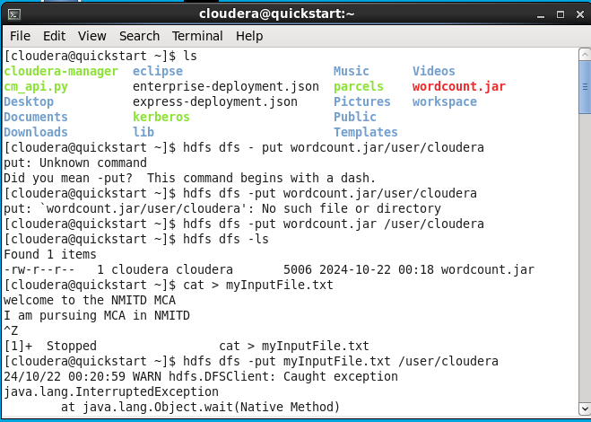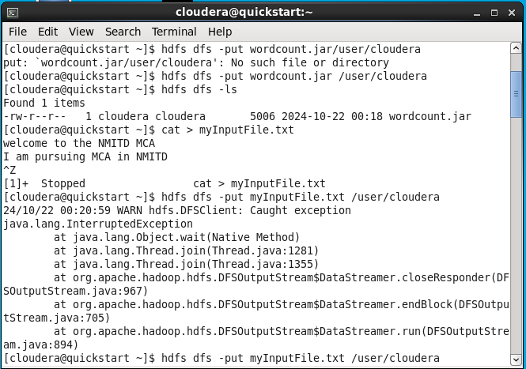

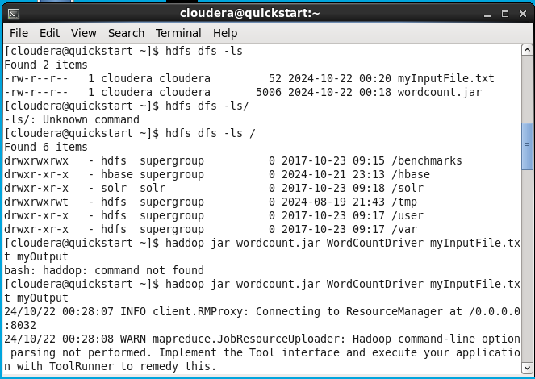

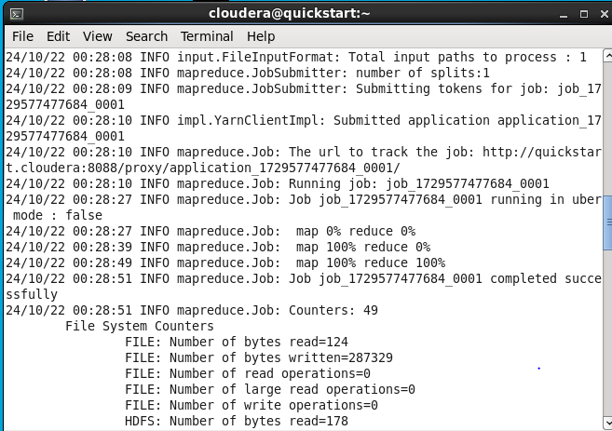

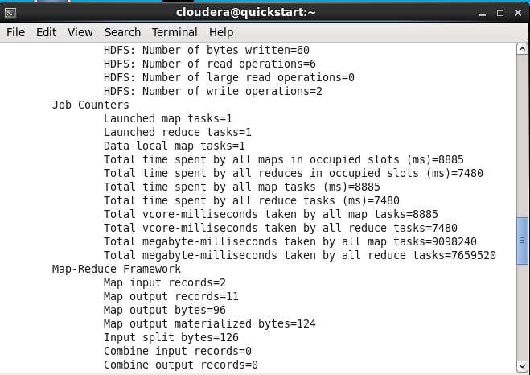

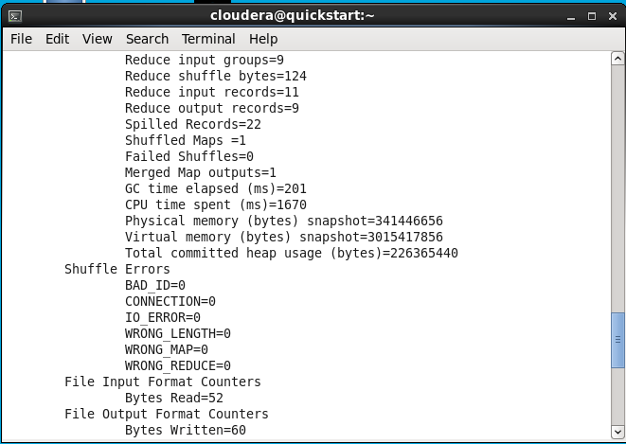

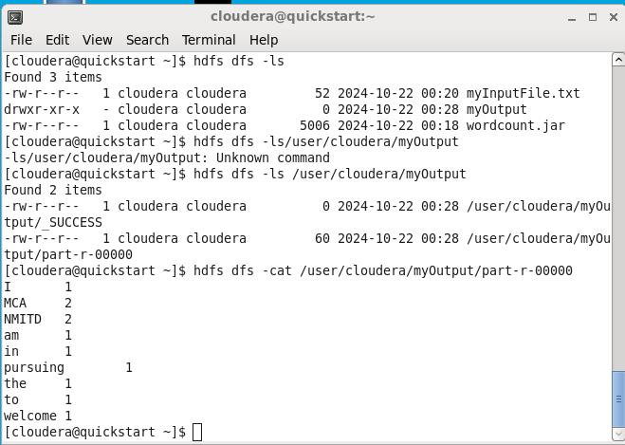

**Conclusion:** Successfully Performed MapReduce Programs in Cloudera VM using Java and PySpark.

# Practical 03

**Aim:** To install and execute MongoDB commands.

## Theory:

**MongoDB** –

MongoDB is a document-oriented NoSQL database used for high volume data storage. Instead of usingtables and rows as in the traditional relational databases, MongoDB makes use of collections anddocuments. Documents consist of key-value pairs which are the basic unit of data in MongoDB. Collections contain sets of documents and function which is the equivalent of relational database tables.MongoDBis adatabasewhichcameintolight aroundthe mid- 2000s.

**MongoDB Features -**

Each database contains collections which in turn contains documents. Each document can bedifferent with a varying number of fields. The size and content of each document can bedifferent from each other. The document structure is more in line with how developers construct their classes and objects in their respective programming languages. Developers will often say that their classes are not rows andcolumns but have a clear structure with key-value pairs. The rows (or documents as called in MongoDB) doesn’t need to have a schema definedbeforehand. Instead, the fields can be created on the fly. The data model available within MongoDB allows you to represent hierarchicalrelationships, to store arrays, and other more complex structures more easily.

**Scalability** – The MongoDB environments are very scalable. Companies across the worldhave defined clusters with some of them running 100+ nodes with around millions ofdocuments within the database

**MongoDB Example** -

Thebelow exampleshows howadocument can be modelled in MongoDB.

The id-field is addedbyMongoDBtouniquely identify the documentinthe collection.

What you can note is that the Order Data (OrderID, Product, and Quantity) which in RDBMSwill normally be stored in a separate table, while in MongoDB it is actually stored as anembedded document in the collection itself. This is one of the key differences in how datais modelled in MongoDB.

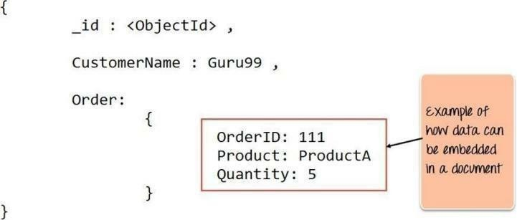

## Installation:

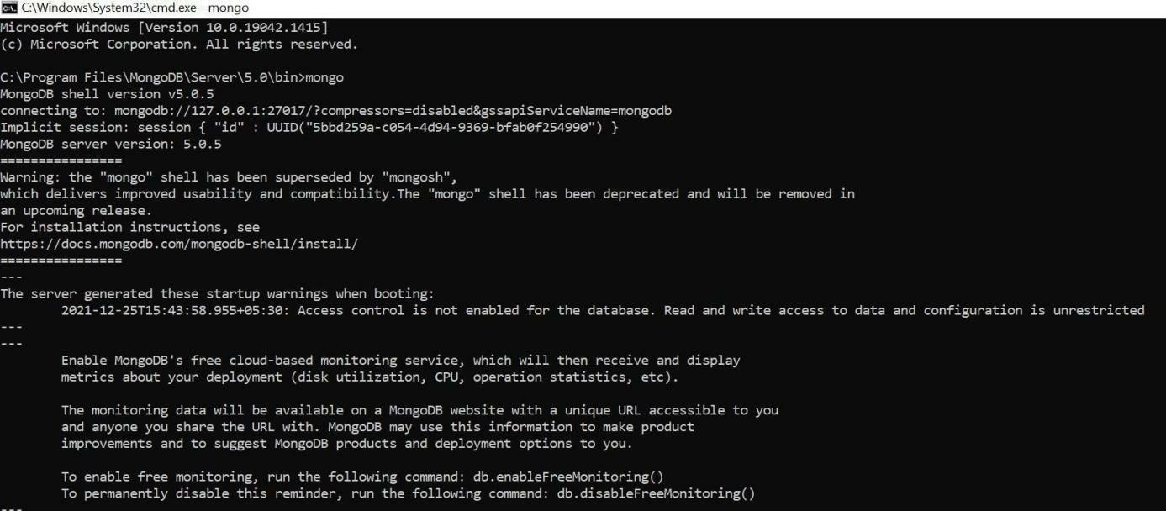

**Sample Database Creation:**

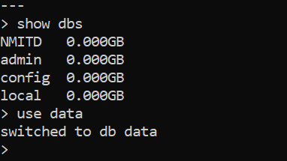

Query the Sample Database using MongoDB querying commands:

## Create Collection

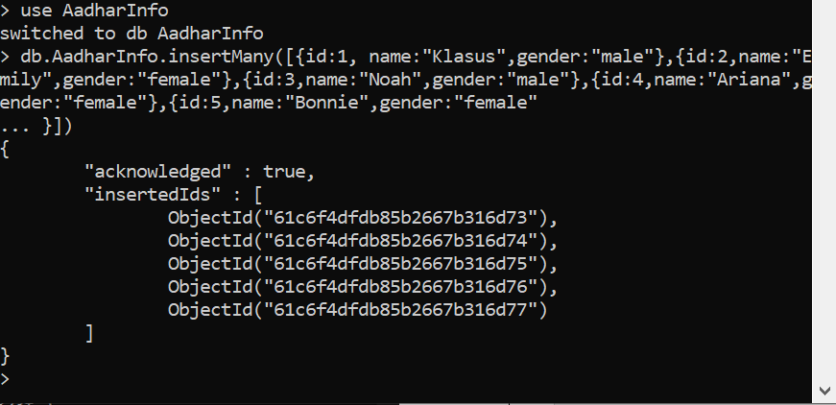

**Insert Document**

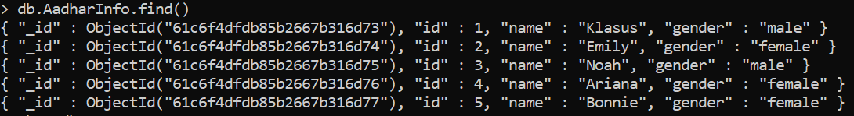

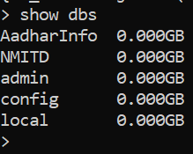

## Query Document

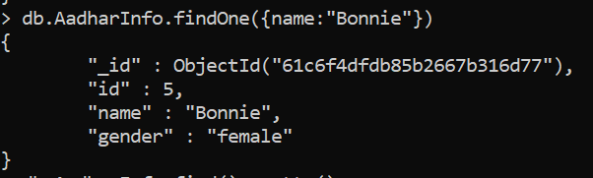

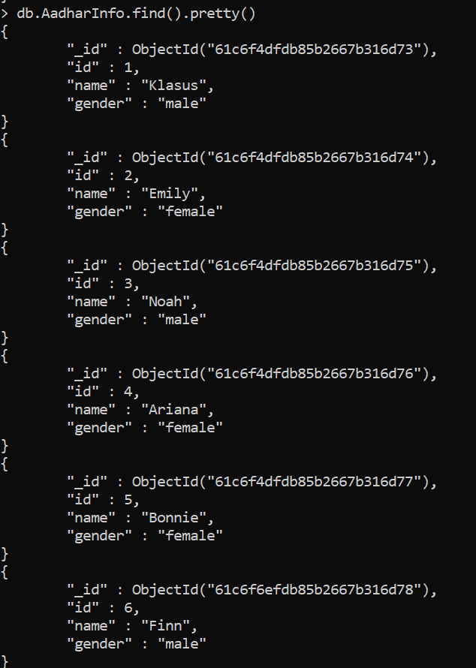

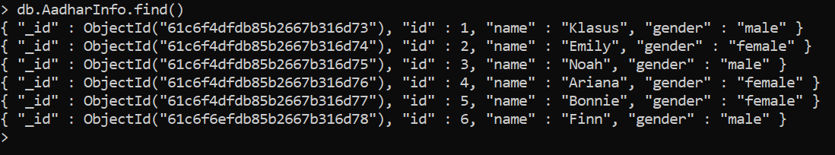

Delete Document

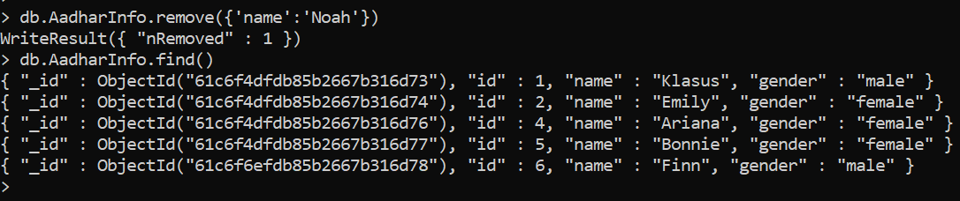

## Update

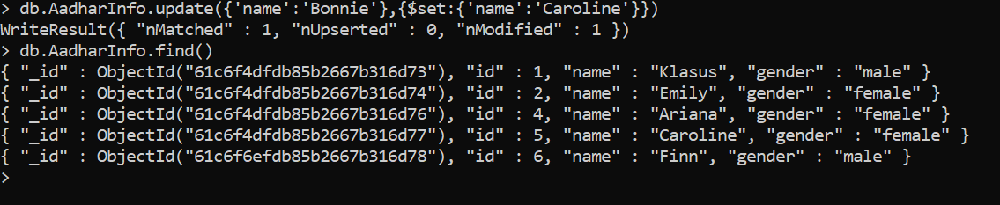

Indexing

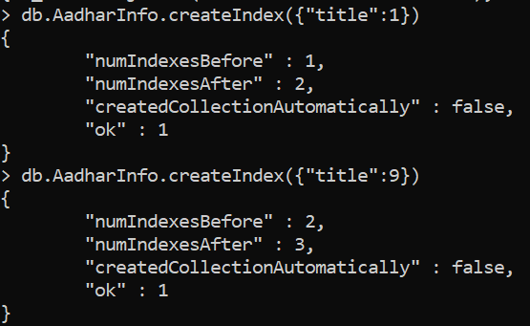

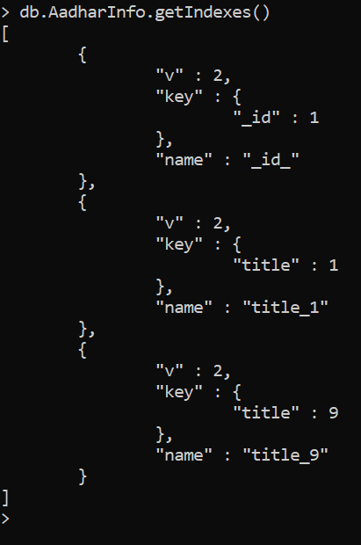

Drop Index

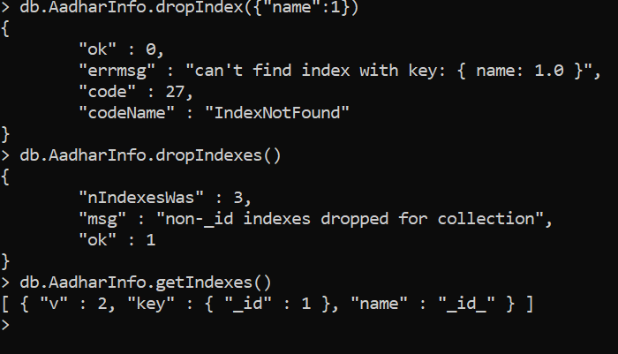

**Conclusion:** Successfullyexecuted MongoDB commands.

# Practical 04

**Aim:** Implementation of Hive: Creation of Database and Table, Hive Partition, Hive Builtin Function and Operators, Hive View and Index.

## Theory:

**Introduction to hive:**

Hive is a data warehouse infrastructure tool to process structured data in Hadoop. It resides ontop of Hadoop to summarize Big Data, and makes querying and analyzing easy.

Initially Hive was developed by Facebook, later the Apache Software Foundation took it up and developed it further as an open source under the name Apache Hive. It is used by differentcompanies. For example, Amazon uses it in Amazon Elastic MapReduce.

Using Hive, we can skip the requirement of the traditional approach of writing complex MapReduce programs. Hive supports Data Definition Language (DDL), Data Manipulation Language (DML), and User Defined Functions (UDF).

Hive is not:

A relational database.

Adesign for Online Transaction Processing (OLTP).A language for real-time queries and row-level updates. Hive is not capable of handling real-time data.

It is not designed for online transaction processing.Hive queries contain high latency. **o**

Features of Hive:

Hiveis fast and scalable.

It provides SQL-like queries (i.e., HQL) that are implicitly transformed to MapReduce orSpark jobs. It is capable of analyzing large datasets stored in HDFS.

It allows different storage types such as plain text, RCFile, and HBase.It uses indexing to accelerate queries. It canoperate on compresseddatastored in the Hadoopecosystem.

It supports user-defined functions (UDFs) where user can provide its functionality.

Architecture of Hive:

## The following component diagram depicts the architecture of Hive:

To activate Hive, hive command is used in terminal.

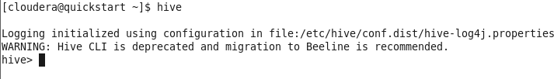

Creation of Database and Table:

## Database Creation in hive –

Hive is a database technology that can define databases and tables to analyze structured data. The theme forstructured data analysis is to store the data in a tabular manner, and pass queries to analyze it. This chapter explains how to create Hive database. Hive contains a default database named default.

Create Database Statement – Create Database is a statement used to create a database in Hive. A database inHive is anamespace or a collection of tables. Thesyntax forthis statement is as follows:

CREATE DATABASE|SCHEMA [IF NOT EXISTS] <database name>

Here, IF NOT EXISTS is an optional clause, which notifies the user that a database with the same name already exists. We can use SCHEMA in place of DATABASE in this command. The following query is executed to create a database named userdb:

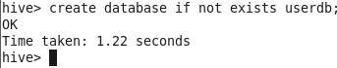

OR



The following query is used to verify a databases list:

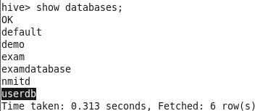

## Table Creation in hive –

Create Table is a statement used to create a table in Hive. The syntax and example are as follows:

CREATE [TEMPORARY] [EXTERNAL] TABLE [IF NOT EXISTS] [db_name.] table_name [(col_name data_type [COMMENT col_comment], ...)] [COMMENT table_comment] [ROW FORMAT row_format][STORED AS file_format]

Example:

Let us assume you need to create a table named employee using CREATE TABLE statement. Thefollowing table lists the fields and their data types in employee table.

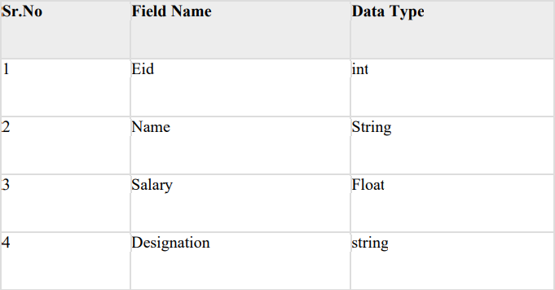

The following data is a Comment, Row formatted fields such as Field terminator, Lines terminator, and Stored File type.

COMMENT ‘Employee details’ FIELDS TERMINATED BY ‘\t’ LINES TERMINATED BY‘\n’ STORED IN TEXT FILE.

The following query creates a table named employee using the above data.

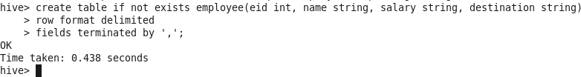

If you add theoption IF NOT EXISTS, Hive ignores the statement in casethe table already exists. On successful creation of table, you get to see the following response:

## Hive Partition:

Hive organizes tables into partitions. It is a way of dividing a table into related parts based on the values of partitioned columns such as date, city, and department. Using partition, it is easy to query a portion of the data.

Tables or partitions are sub-divided into buckets, to provide extra structure to the data that may be used for moreefficient querying. Bucketing works based on the value of hash function of some column of a table.

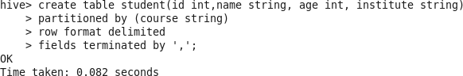

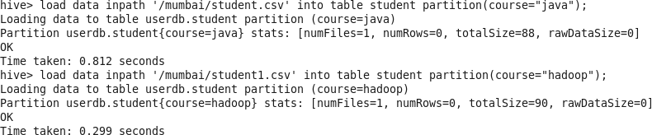

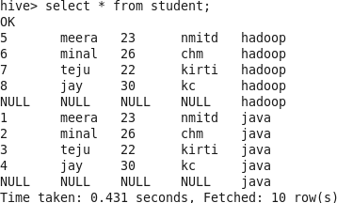

Hive Built-In Operators

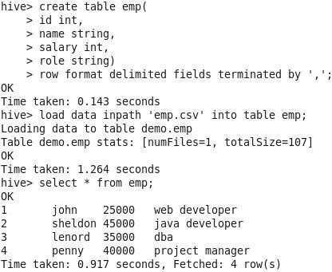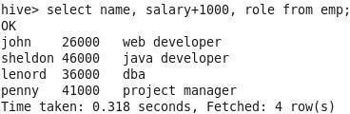

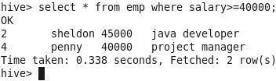

Hive Built-In Functions sqrt()

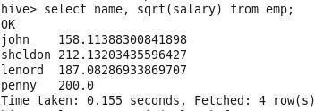

min()

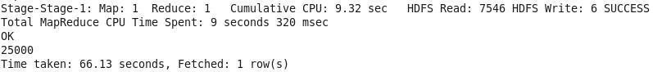

max()

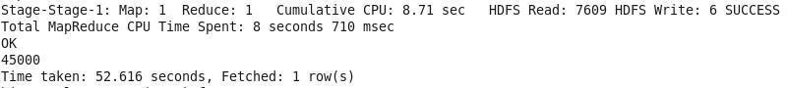

upper()

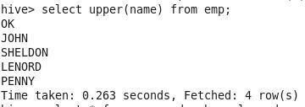

Hive Views and Indexes

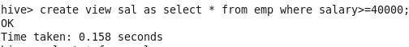

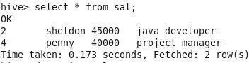

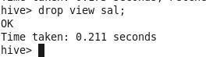

**Order by**

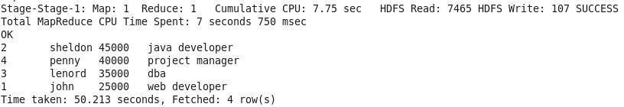

## Group By

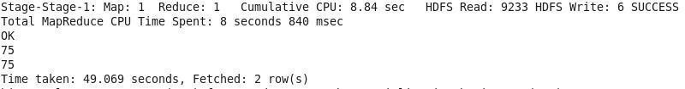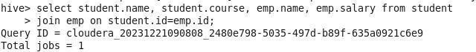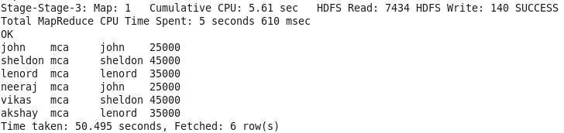

**Views**

Create

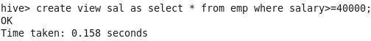

Display View

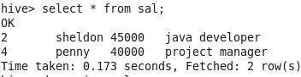

Index Create

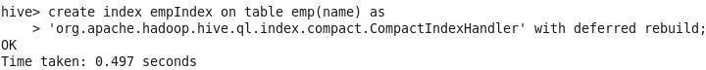

Show Index



Drop Index

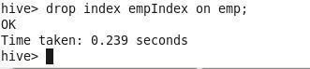

# Practical 5

The language used to analyze data in Hadoop using Pig is known as Pig Latin. It is a high-level data processing language which provides a rich set of data types and operators to perform various operations onthe data.

To perform a particular task Programmers using Pig, programmers need to write a Pig script using the Pig Latin language and execute them using any of the execution mechanisms (Grunt Shell, UDFs, Embedded). After execution, these scripts will go through a series of transformations applied bythe Pig Framework,toproducethedesiredoutput.

Internally, Apache Pig converts these scripts into a series of MapReduce jobs, and thus, itmakes the programmer’s job easy.

Case Sensitivity

Keywords in Pig Latin are not case-sensitive; for example, LOAD is equivalent to load. But relation andfield names are, so A = load 'foo'; is not equivalent to a = load 'foo';. UDF names are also case-sensitive; thus, COUNT is not the same UDF as count.

Apache Pig Components

As shown in the figure, there are various components in the Apache Pig framework. Let us take a look at themajor components.

Parser

Initially the Pig Scripts are handled by the Parser. It checks the syntax of the script, does type checking, and other miscellaneous checks. The output of the parser will be a DAG (directed acyclic graph), which represents the Pig Latin statements and logical operators.

In the DAG, the logical operators of the script are represented as the nodes and the data flows are represented asedges.

Optimizer

The logical plan (DAG) is passed to the logical optimizer, which carries out the logical optimization nssuch as projection and pushdown.

Compiler

The compiler compiles the optimized logical plan into a series of MapReduce jobs. Execution engine Finally, the MapReduce jobs are submitted to Hadoop in a sorted order.



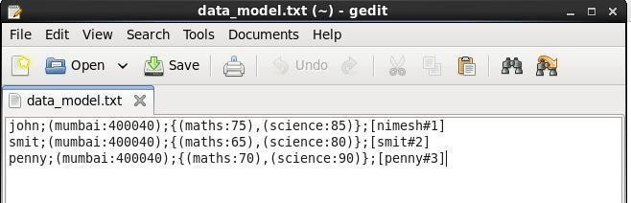



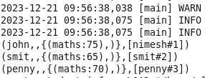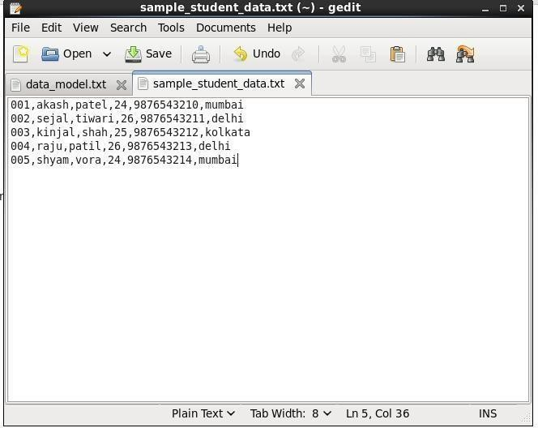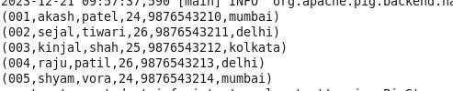



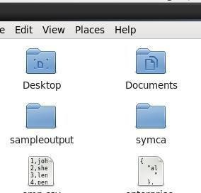

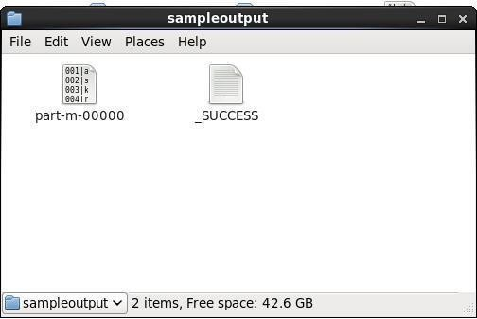

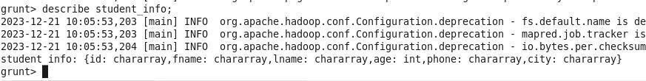Pig Operations Describe

Filter

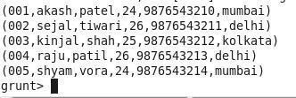

Explain

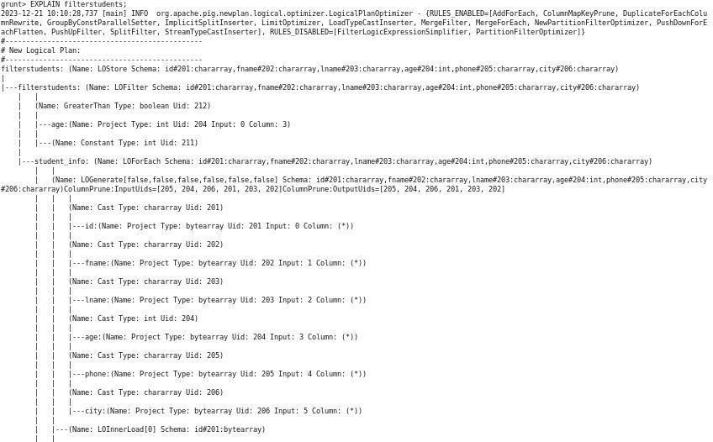

ForEach



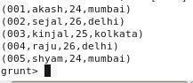

Group

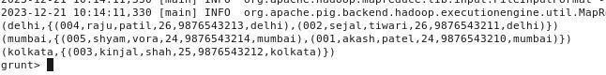

Illustrate

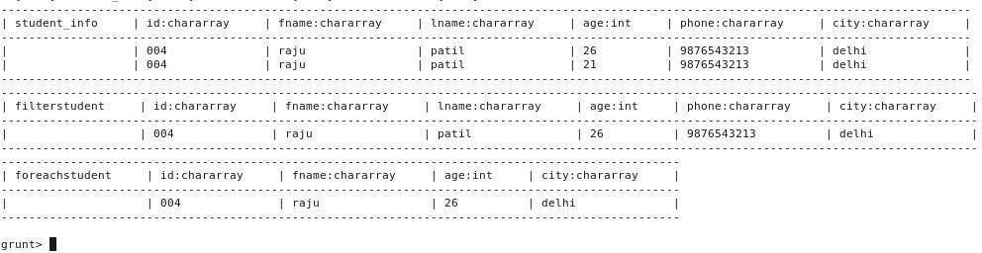

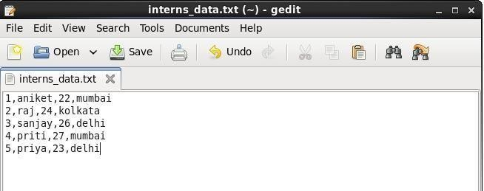



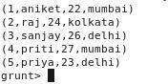

COGroup



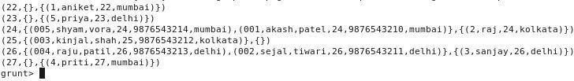

Join

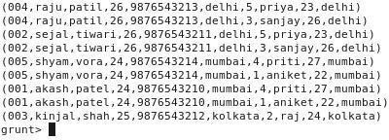

Left join



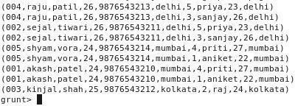

Right join



Split

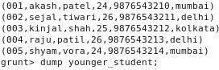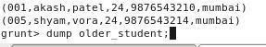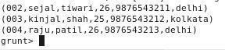

Filter

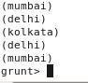

Word Counter

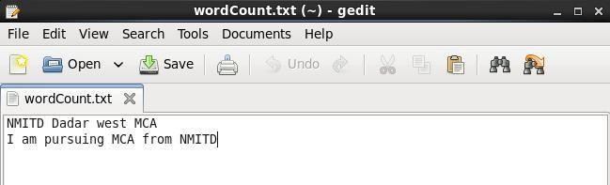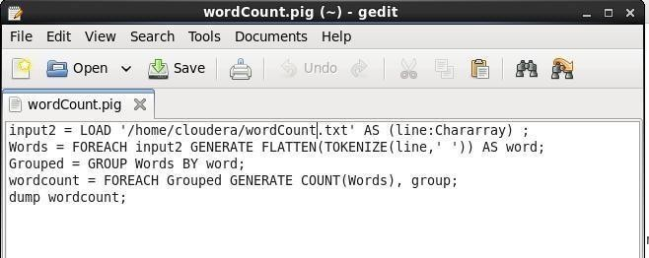

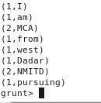

# Practical 6

Spark

**Aim:** To run spark commands and functions

## Theory:

Apache Spark is an open-source unified analytics engine for large-scale data processing. Spark provides an interface for programming entire clusters with implicit data parallelism and fault tolerance. Originally developed at the University of California, Berkeley's AMP Lab, the Spark codebase was later donated to theApache Software Foundation, which has maintained it since. Below snapshots demonstrates various spark shell commands and their uses.

Commands and Steps: Open cloudera’s desktop terminal Open cloudera VM -> terminal ; type spark-shell and enter spark-shell

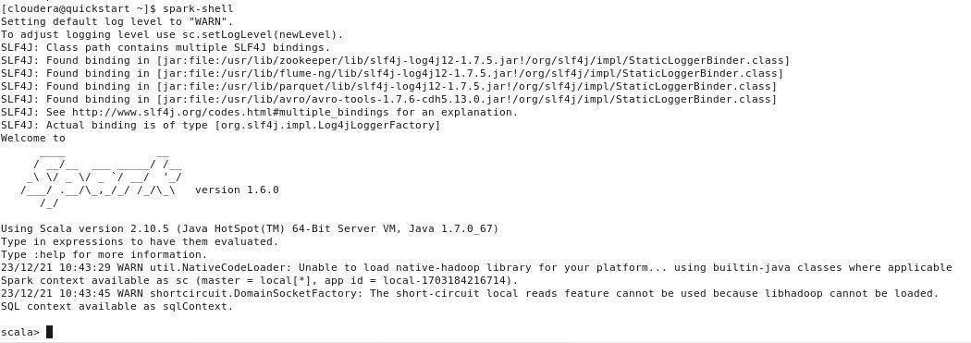

## valdata=sc.parallelize(List(10,20,30))



data.collect



History

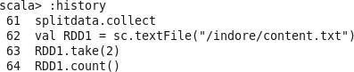

valmapfunc=data.map(x=>x+10



mapfunc.collect



valdata=sc.parallelize(List(20,60,40,100))



data.collect



valfilterfunc=data.filter(x=>x!=40)



filterfunc.collect



valcountfunc=data.count()



data.collect



valdistinctfunc=data.distinct()



valdistinctfunc=data.count()



distinctfunc.collect



valdata1=sc.parallelize(List(20,60,40,100,20))



valdistinctfunc=data1.distinct()



scala>distinctfunc.collect



valdata2= sc.parallelize(List(1,2)) data2.collect

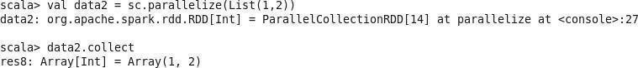

val data3 = sc.parallelize(List(2,3,5))

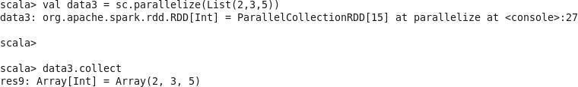

**Valunionfunc = data2.union(data3)**

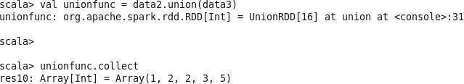

## Valintersectfunc = data2.intersection(data3)

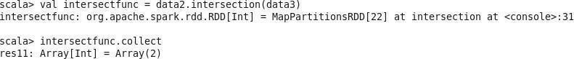

valcartesianfunc= data2.cartesian(data3) data3.collect

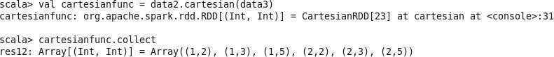

valdata=sc.parallelize(Seq(("C",3),("A",1),("D",4),("B",2),("E",5))) data.collect



## valsortfunc= data.sortByKey()

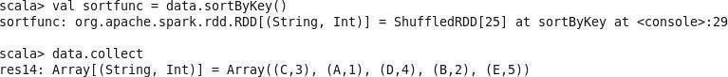

sortfunc.collect

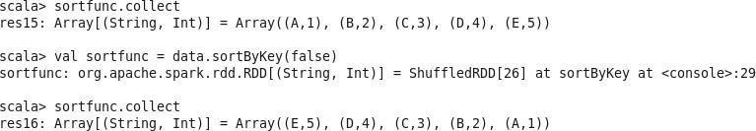val sortfunc = data.sortByKey(false) sortfunc.collect

**valgroupfunc= data.groupByKey()**



## valdata=sc.parallelize(Seq(("C",3),("A",1),("D",4),("B",2),("E",5),("B",6)))

valgroupfunc= data.groupByKey()

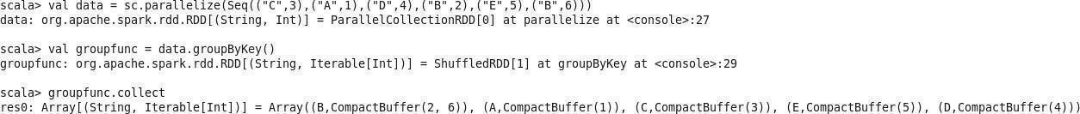

## valreducefunc=data.reduceByKey((value,x)=>(value +x))reducefunc.collect

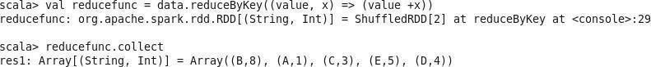

**valdata1=sc.parallelize(Seq(("A",1),("B",2),("C",3))) data1.collect**



## valdata2=sc.parallelize(Seq(("F",6),("E",5),("D",4))) data2.collect

**valcogroupfunc=data1.cogroup(data2)**

cogroupfunc.collect



**valfirstfunc=data.first() valtakefunc=**

## data2.collect().foreach(print)

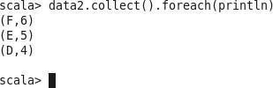

val data = sc.textFile("/indore/content.txt") data.collect valsplitdata=data.flatMap(line=>line.split("")); splitdata.collect valRDD1=sc.textFile(/indore/content.txt") RDD1.take(2)



RDD1.count()



* valsplitdata=RDD1. flatMap(line=>line.split(""))]]];
* splitdata.collect
* for(line<-RDD1.take(2))println(line)
* valmapdata=splitdata.map(word=>(word,1));
* mapdata.collect()
* valreducedata=mapdata.reduceByKey(_+_);
* reducedata.collect()
* valmapdata=RDD1.map(word=>(word,1));
* mapdata.collect
* valsplitdata=RDD1.flatMap(line=>line.split(""));
* splitdata.collect

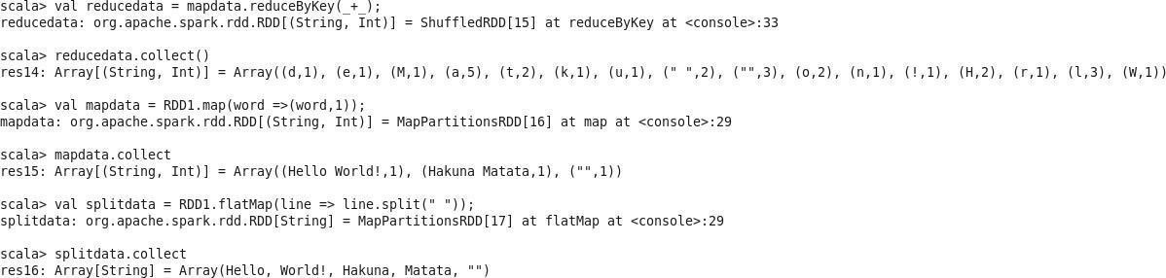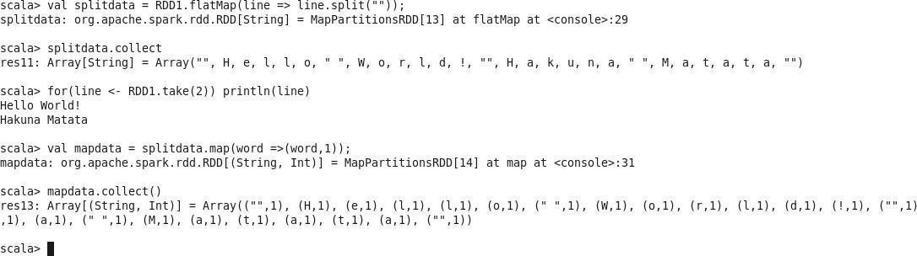

# Practical 07

**Aim:-** Visualization: Connect to data, Build Charts and Analyze Data, Create Dashboard,Create Stories using Tableau.

## Theory:-

Tableau Software is an American interactive data visualization software company focused on business intelligence. It was founded in 2003 in Mountain View, California, and is currently headquartered inSeattle, Washington. In 2019 the companywas acquired by Salesforce for

$15.7 billion. At the time, this was the largest acquisition by Salesforce (a leader in the CRMfield) since its foundation. It was later surpassed by Salesforce's acquisition of Slack. Tableau products query relational databases,online analytical processing cubes, cloud databases, and spreadsheets to generate graph-type data visualizations. The software can also extract, store, and retrieve data from an in- memory data engine. Tableau has a mapping functionality and can plot latitude and longitude coordinates and connect to spatial files like Esri Shapefiles, KML, and GeoJSON todisplay custom geography.

The built-in geocoding allows for administrative places (country, state/province, county/district), postal codes, US Congressional Districts, US CBSA/MSA, Area Codes, Airports, and European Union statistical areas (NUTS codes) to be mapped automatically. Geographies can be grouped to create customterritories or custom geocoding used to extend existing geographic roles in the product.

Analysis Operations

Q 1: Find the customer with the highest overall profit. What is his/her profit ratio? Ans: Step 1: Openthe superstoreus2015 excel data set

Step 2: Drag Orders sheet to sheet area

Step 3: Go to sheet 1 and add Customer name as rows and profit as column

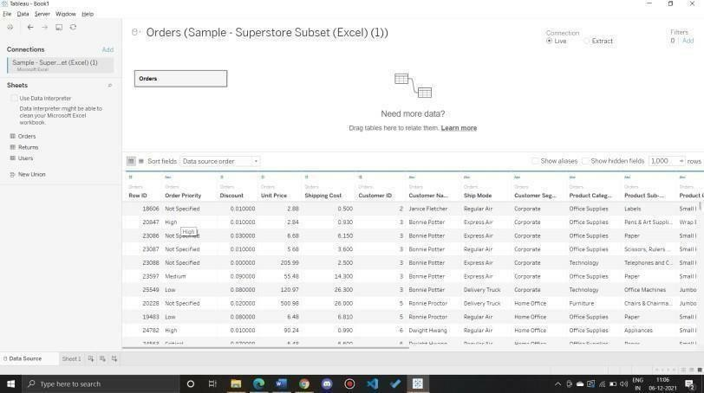

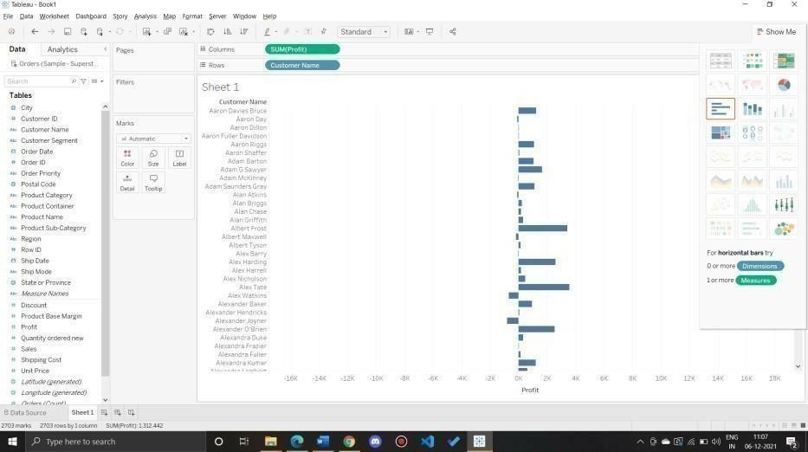

Step 4: Sort the data by clicking on Profit label on bottom

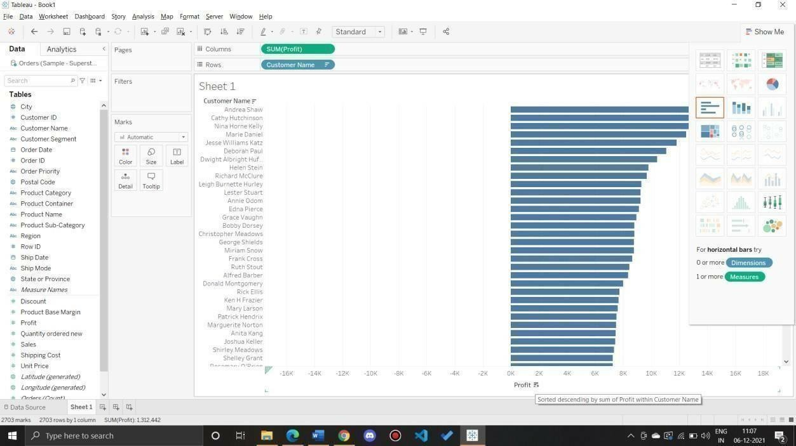

Step 5: To calculate profit Ratio

Profit Ratio= (Sum([Profit])/Sum([Sales]))

This formula needs to be entered as tooltip or label

Click on Analysis>Create Calculated Field and enter the formula

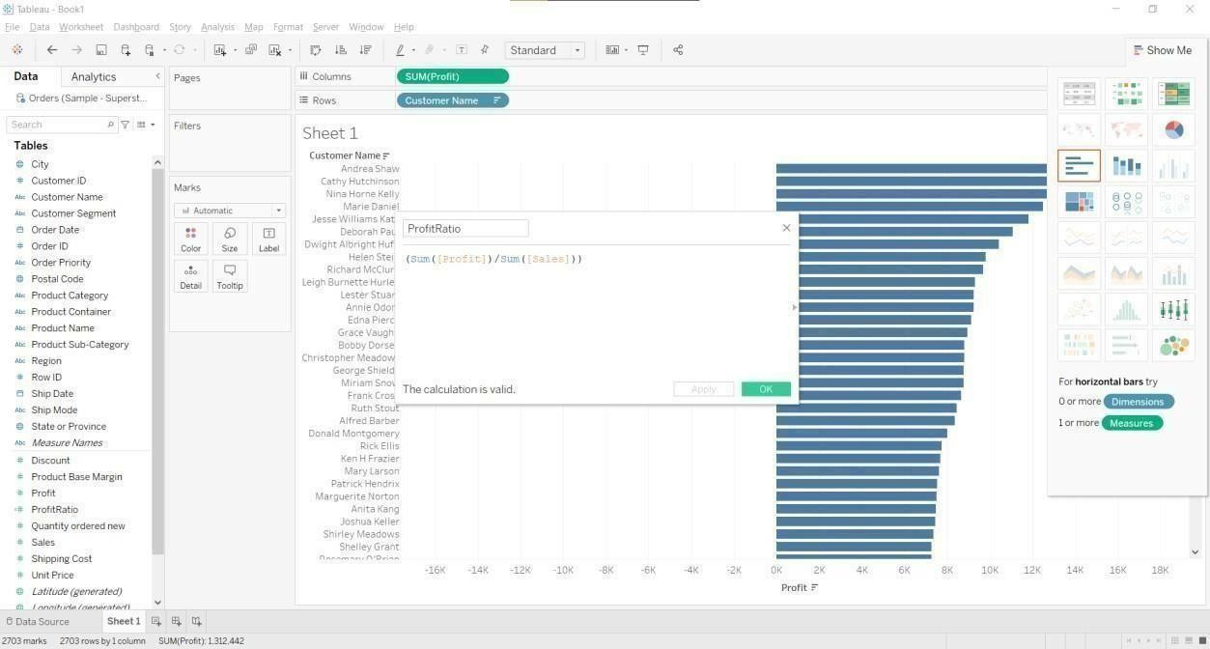

You can see ProfitRatio(Or name you provided) in measures. Drag is to Marks area.

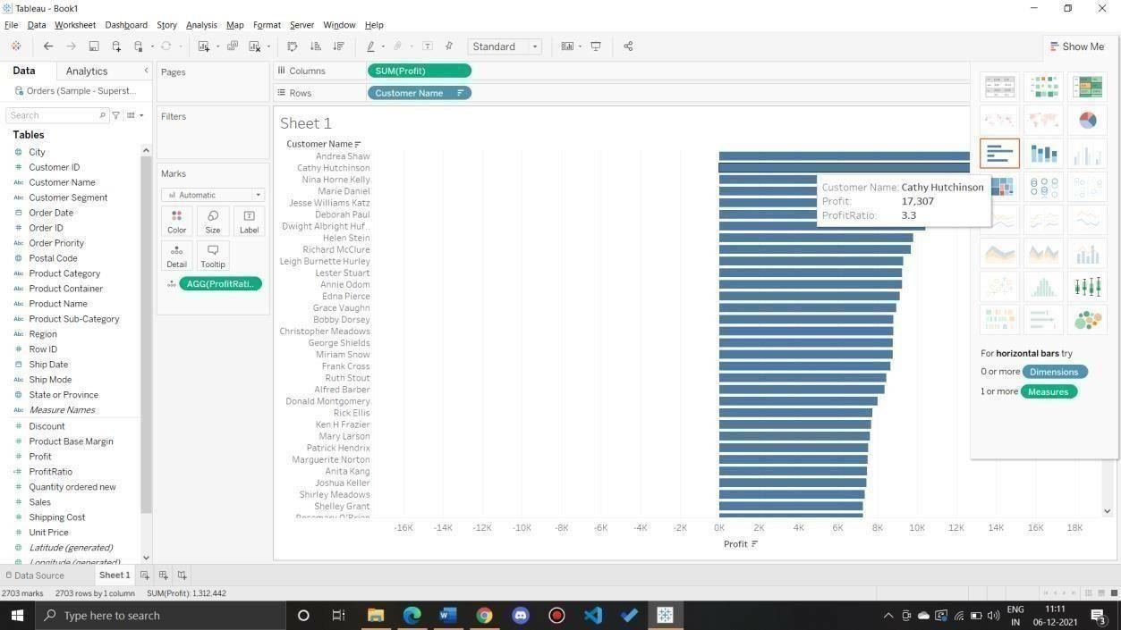

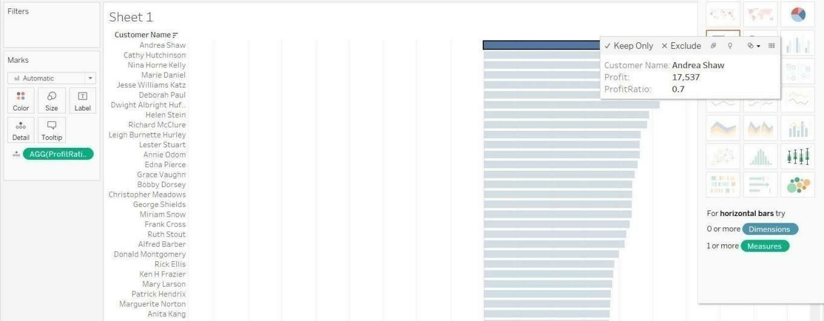

To removesomethingfrom column and row

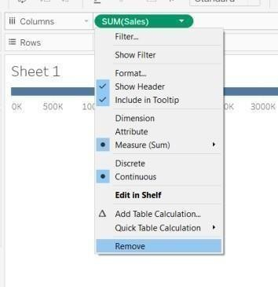

Q2: Which state has the highest Sales (Sum)? What is the total Sales for that state? Ans:

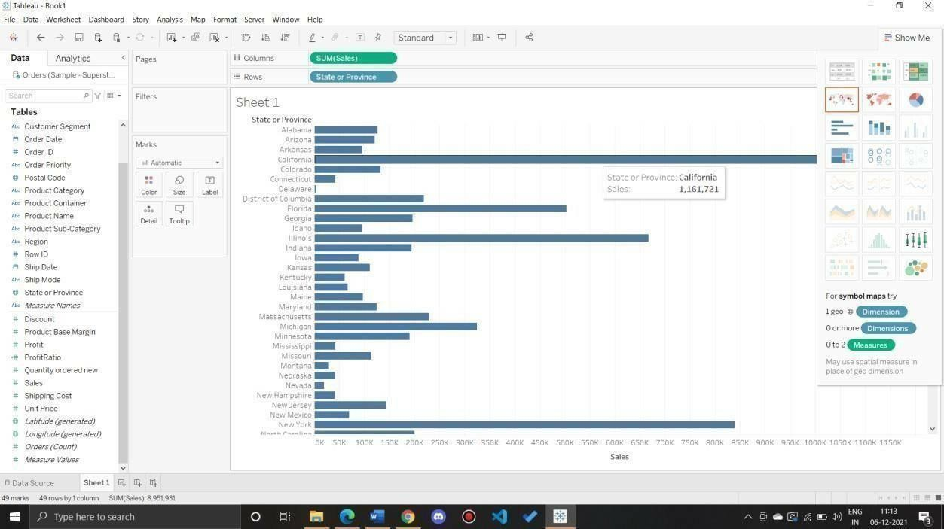

Q 3: Which customer segment has both the highest order quantity and average discount rate? What is the orderquantity and average discount rate for that state?

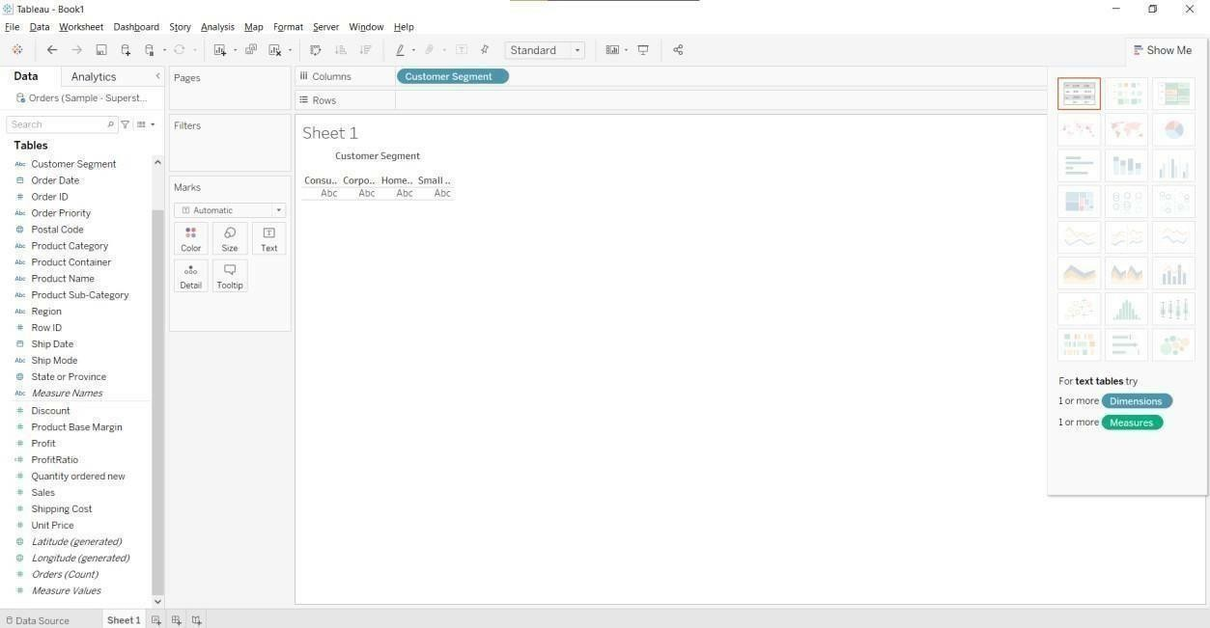

Drag and drop measures name.

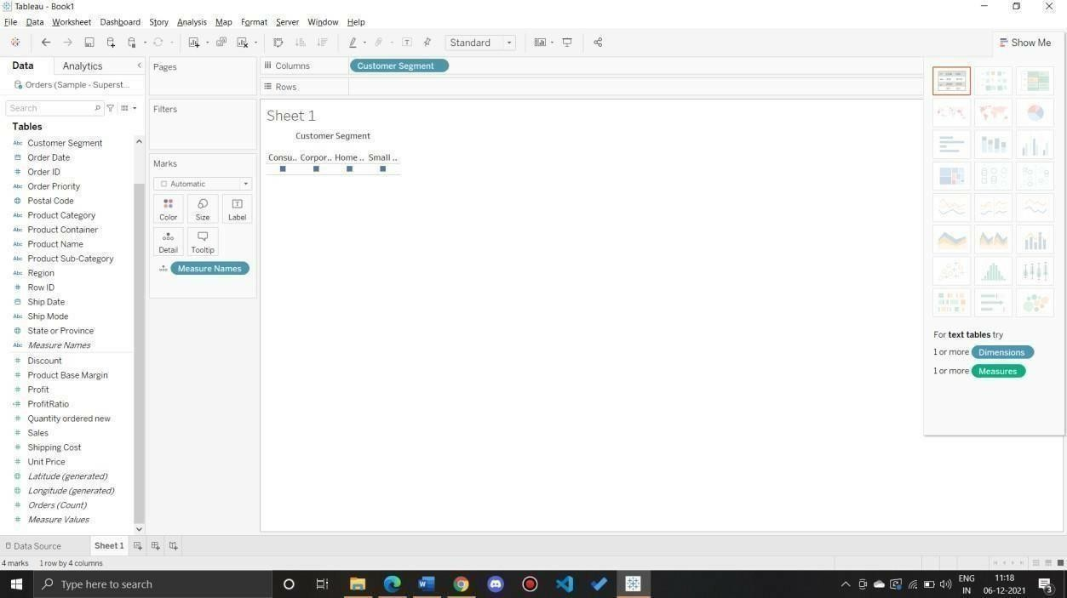

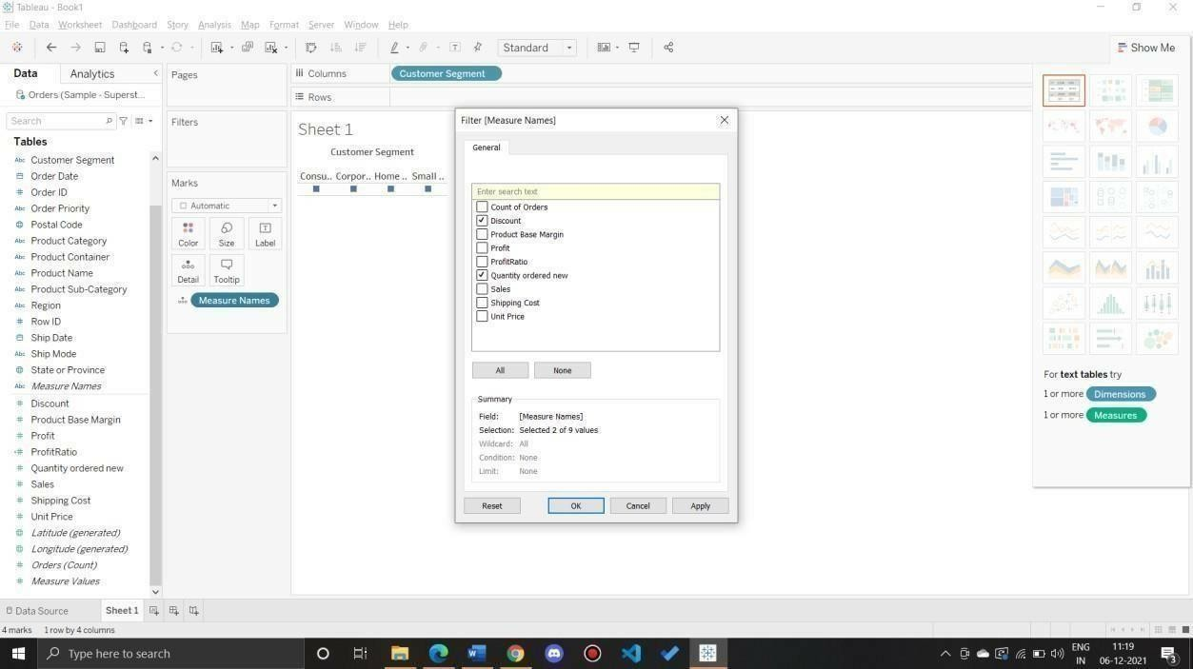

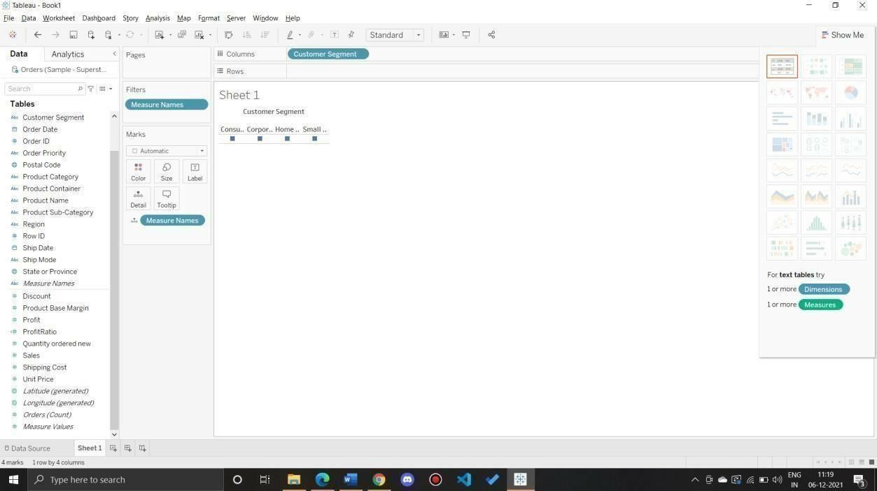

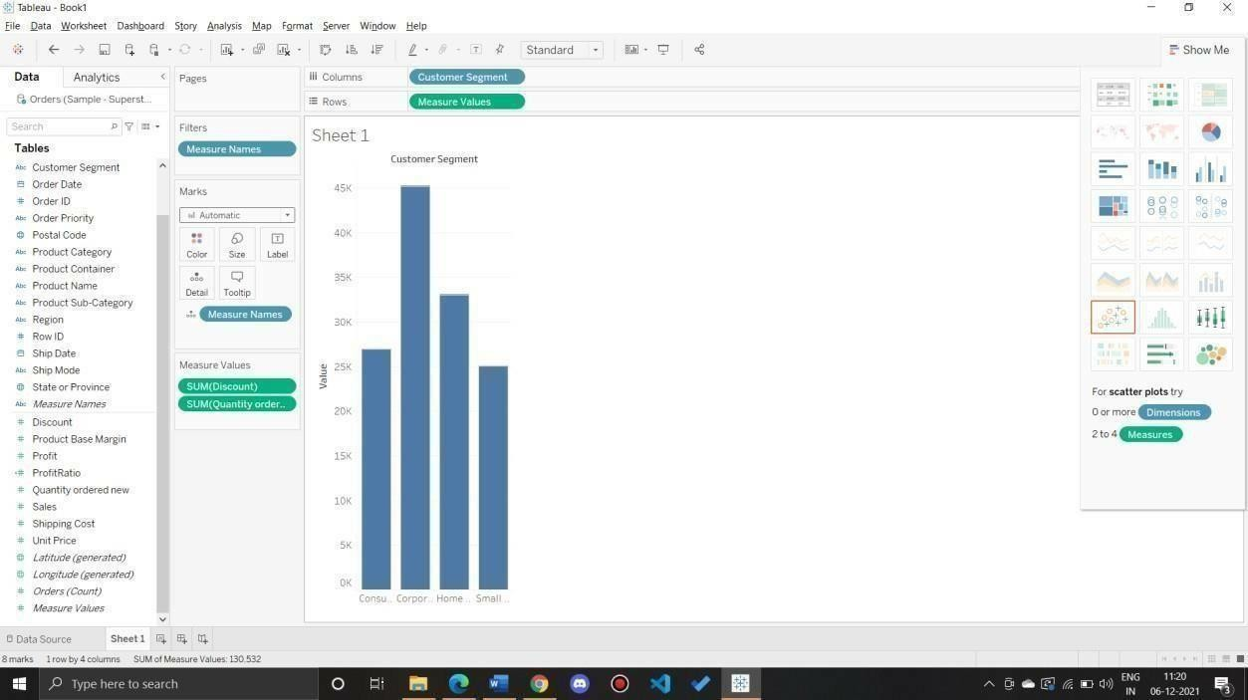

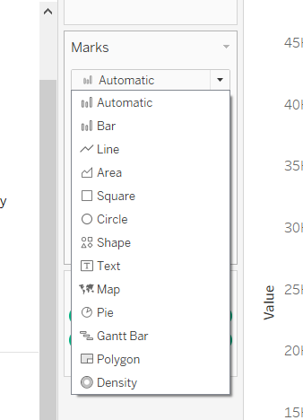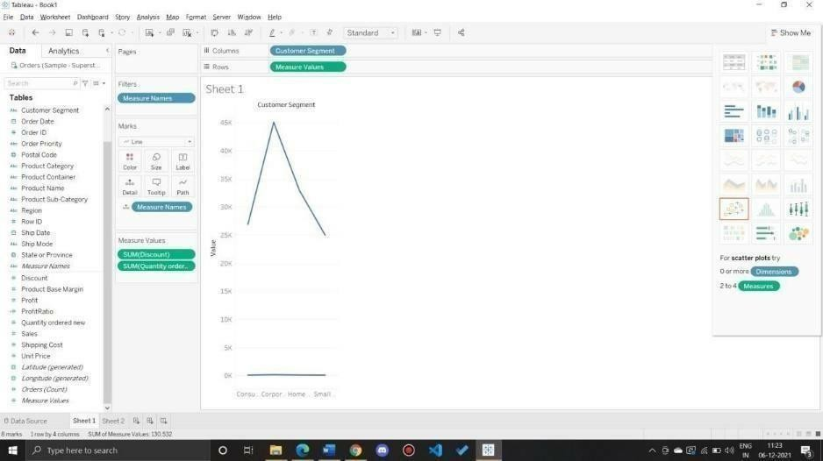

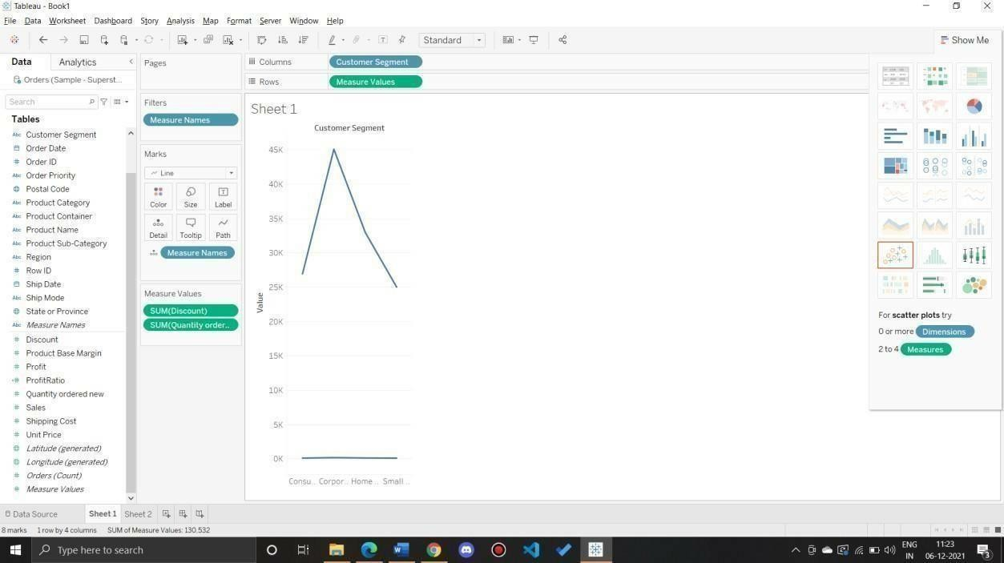

Q 4: Which Product Category has the highest total Sales? Which Product Category has the worst Profit?Name the Product Category and $ amount for each.

Ans:

Bar Chart displaying total Sales for each Product Category

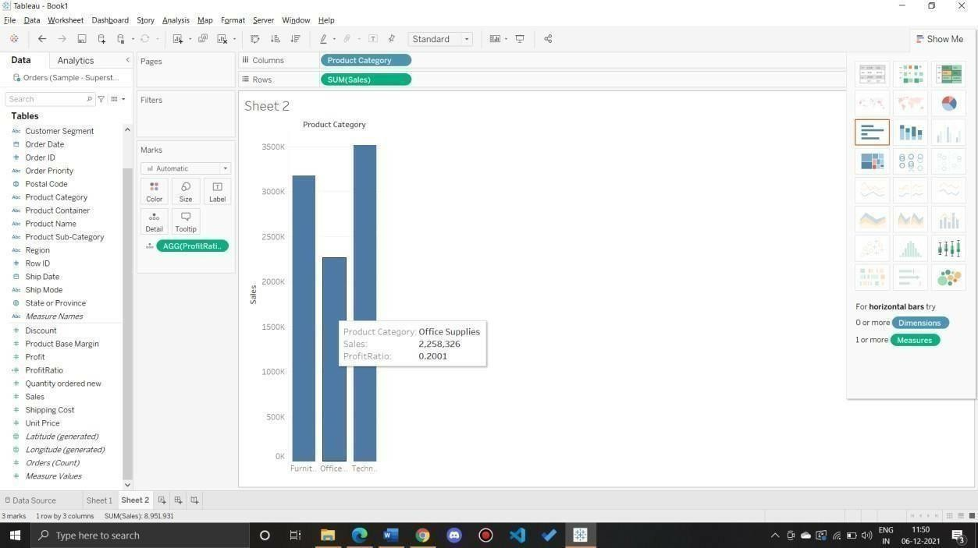

Add a color scale indicating Profit

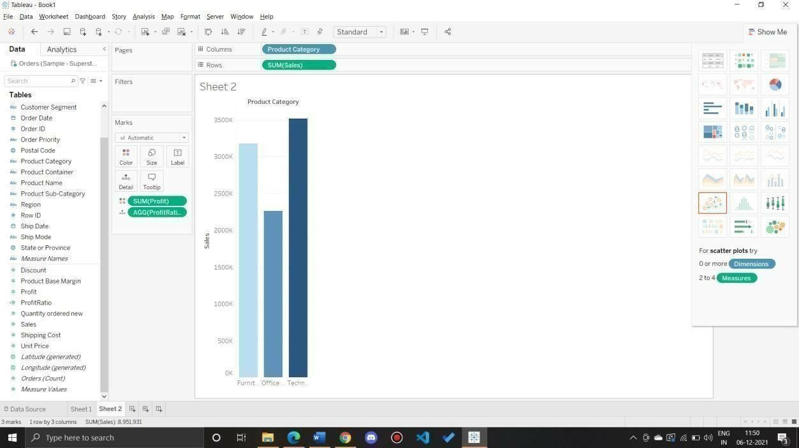

Each Product Category labeled with total Sales and Each Product Category labeled with Profit

Q 5: Use the same visualization created for Question #4.What was the Profit on Technology(Product Category) in Boca Raton (City) ?

Add Filter City

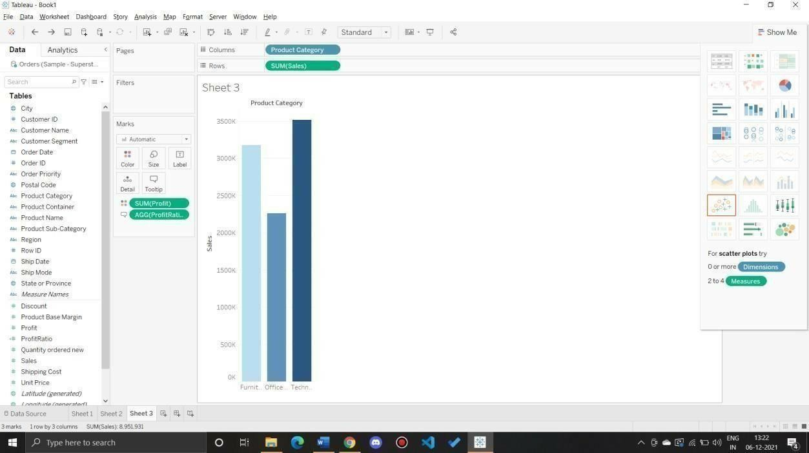

Select the city to show a single bar for the city

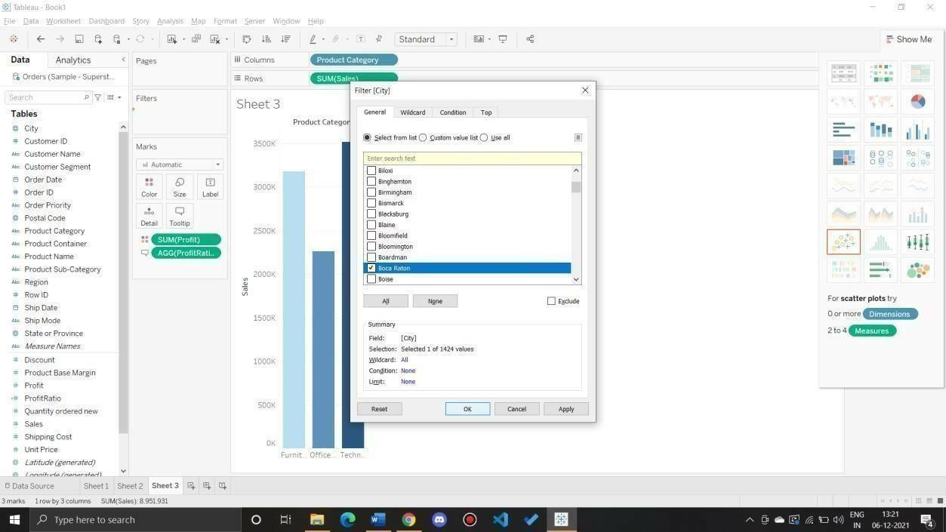

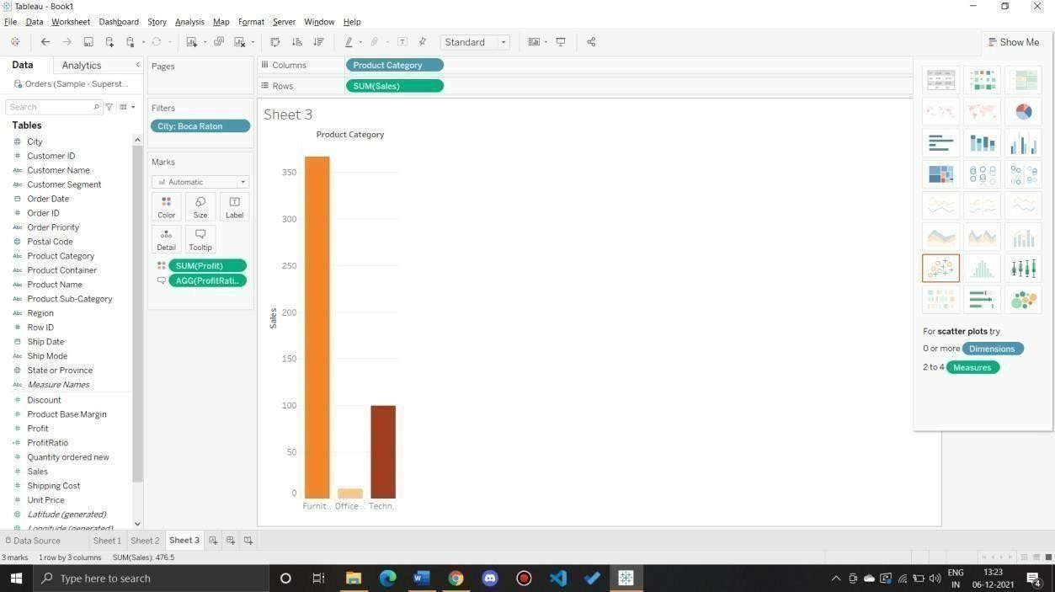

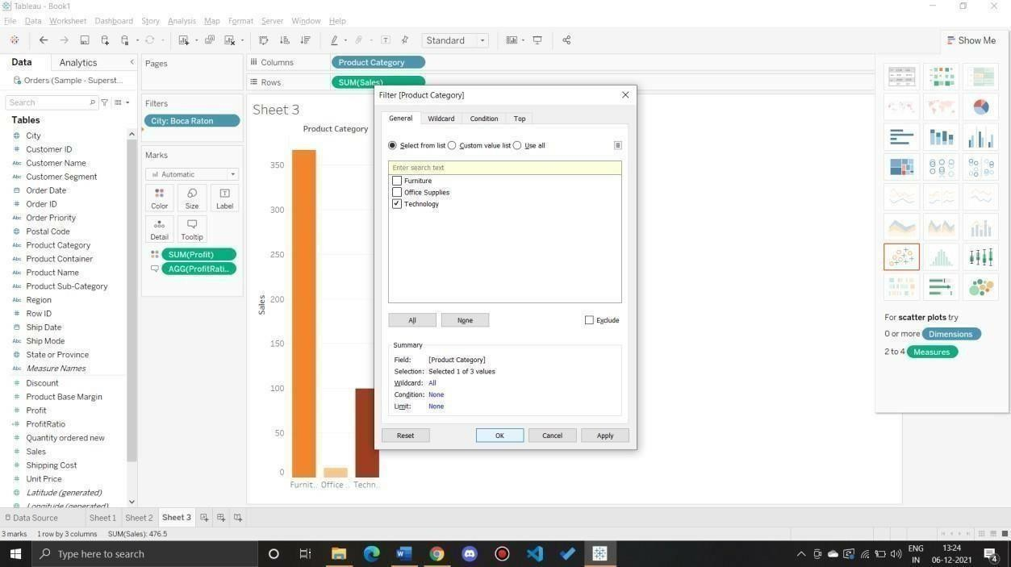

Q 6: Which Product Department has the highest Shipping Costs? Name the Department and cost. Packed bubble chart showing each Product Department as a colored bubble

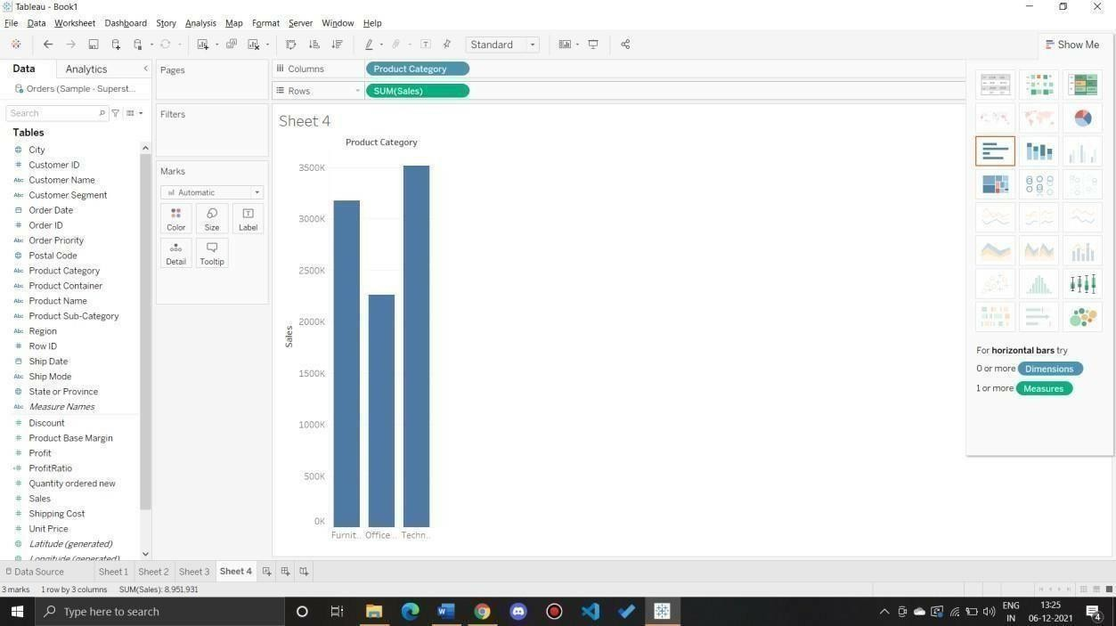

Use Shipping Cost to display the size of each bubble

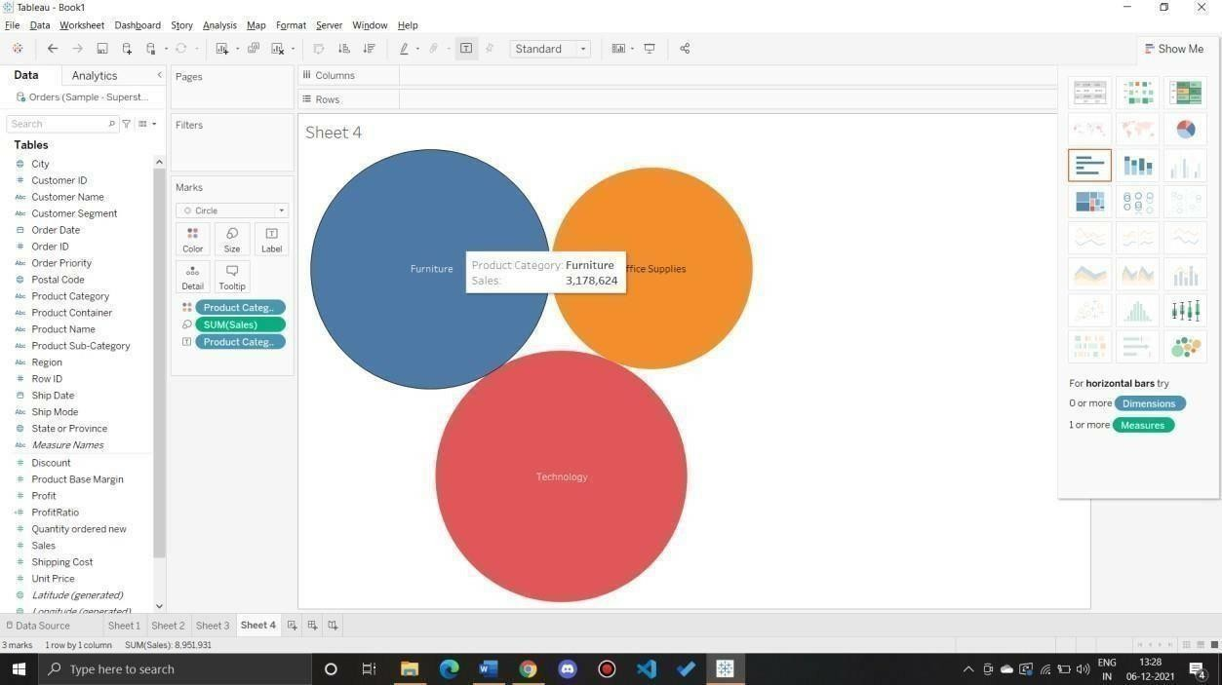

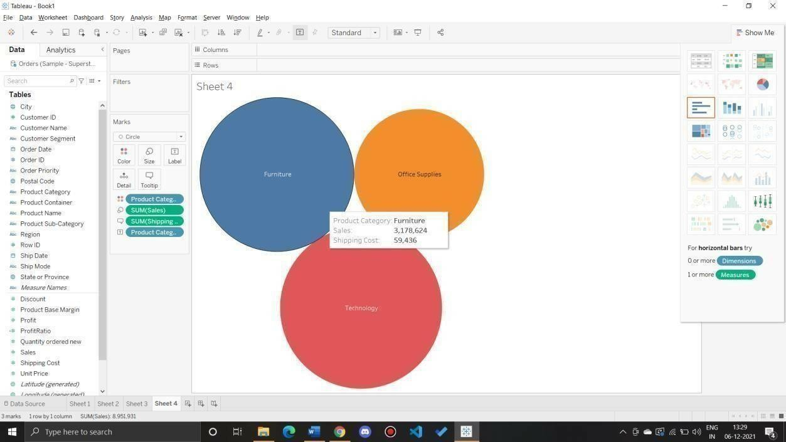

Q 7: Usethe samevisualization created for Question #6. What was the shippingcost of Office Suppliesfor Xerox 1905 in the Home Customer Segment in Cambridge?

Ans: Apply filters as per requirement

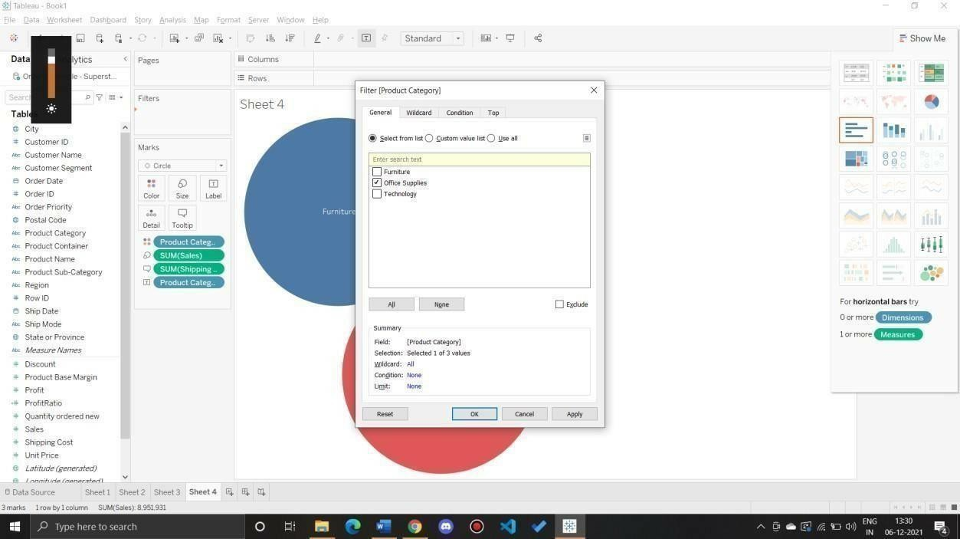

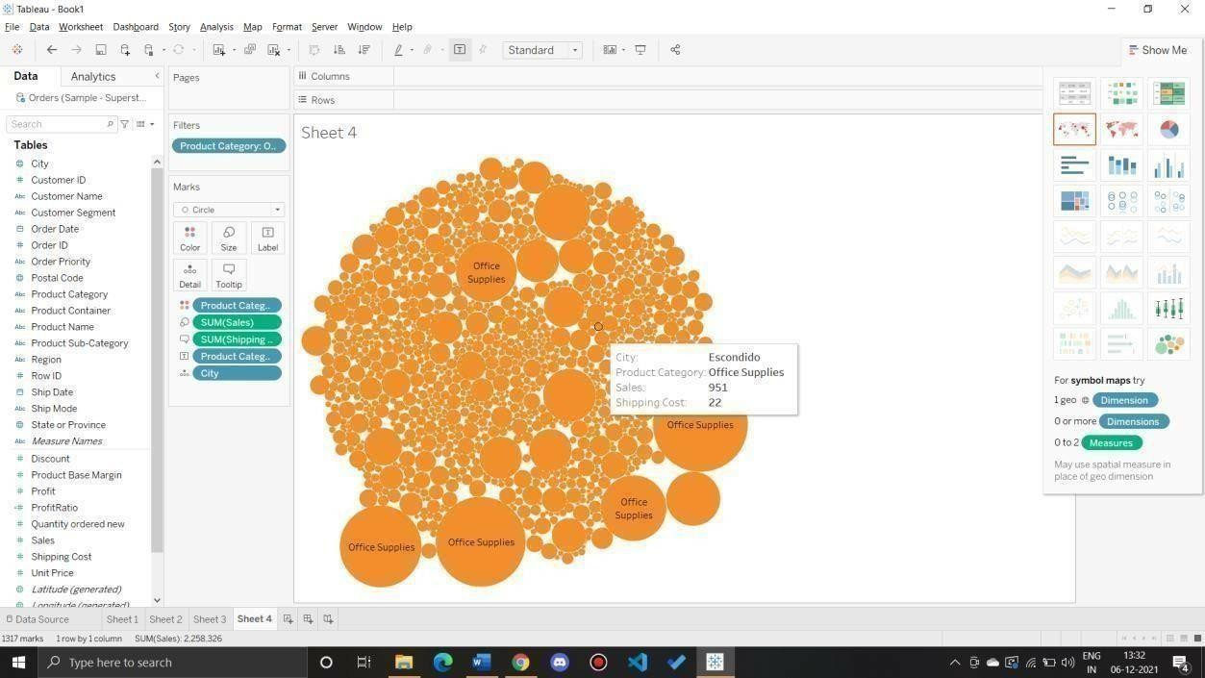

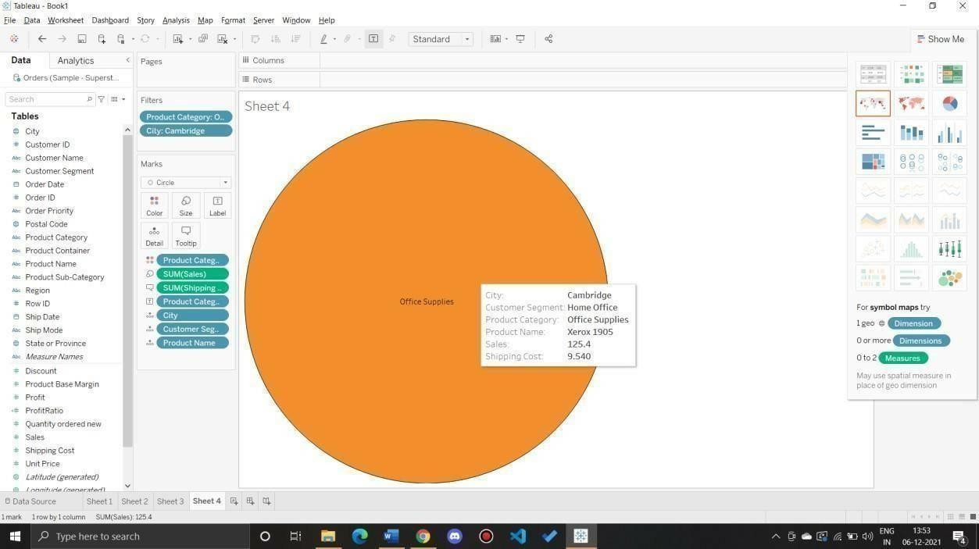

Preparing Maps

Data Set for this Lab Sample- Superstore

Q 1: Prepare a Geographic map to show sales in each state. Ans:

1. Connect to dataset

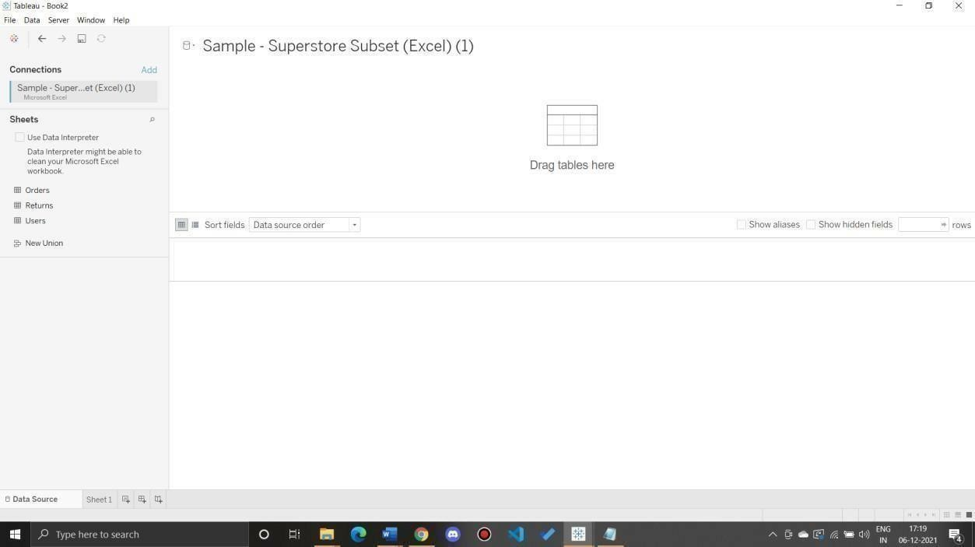

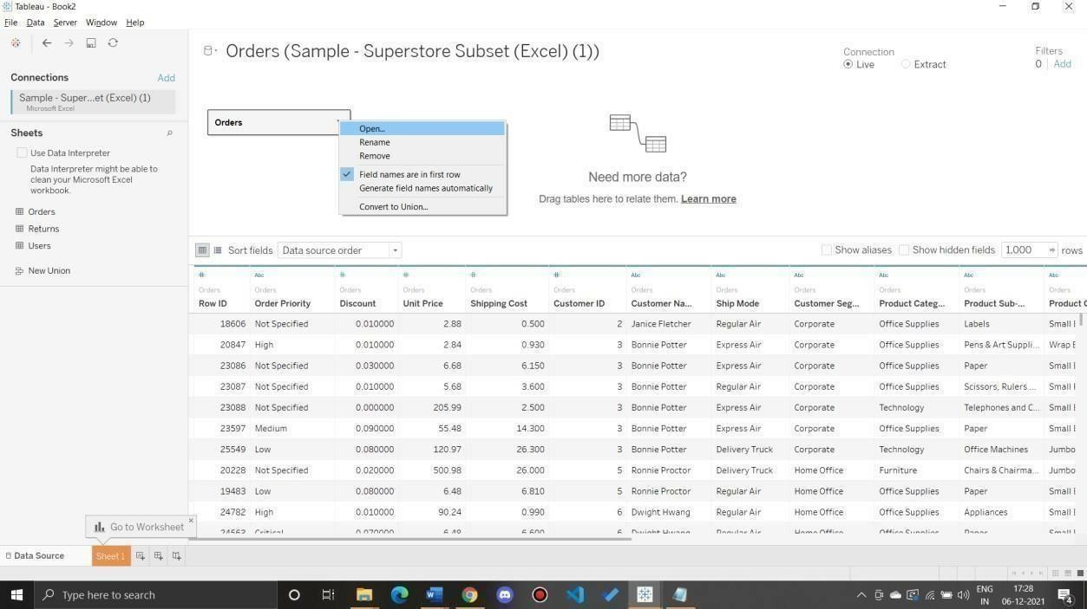

1. join sheets

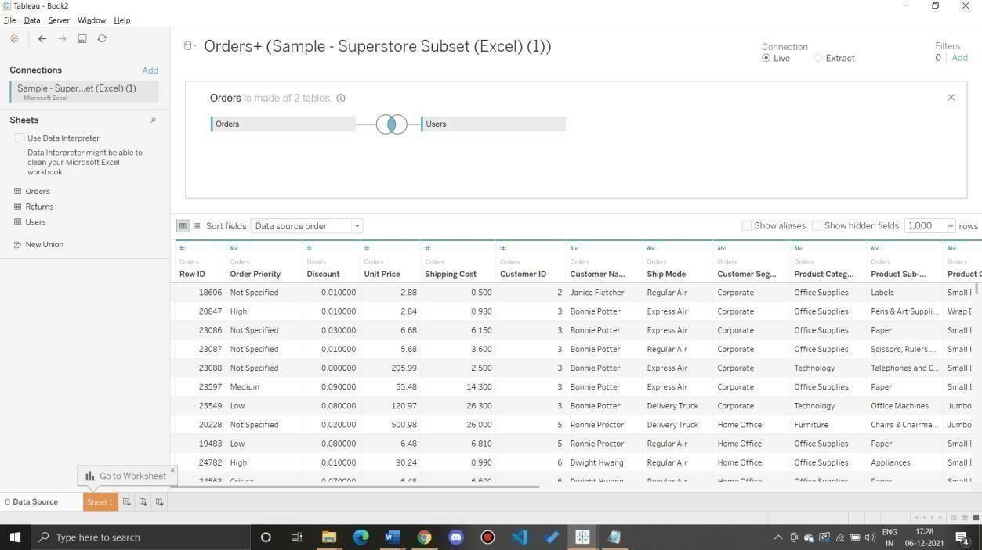

Create a Geographic Hierarchy

In the Data pane, right-click the geographic field, Country, and then selectHierarchy > Create Hierarchy.

In the Create Hierarchy dialog box that opens, give the hierarchy a name, such as MappingItems, and then click OK. At the bottom of the Dimensions section, the Mapping Items hierarchy is createdwith the Country field. In the Data pane, drag the State field to the hierarchy and place it below the Country field.

Repeat step 3 for the City and Postal Code fields.

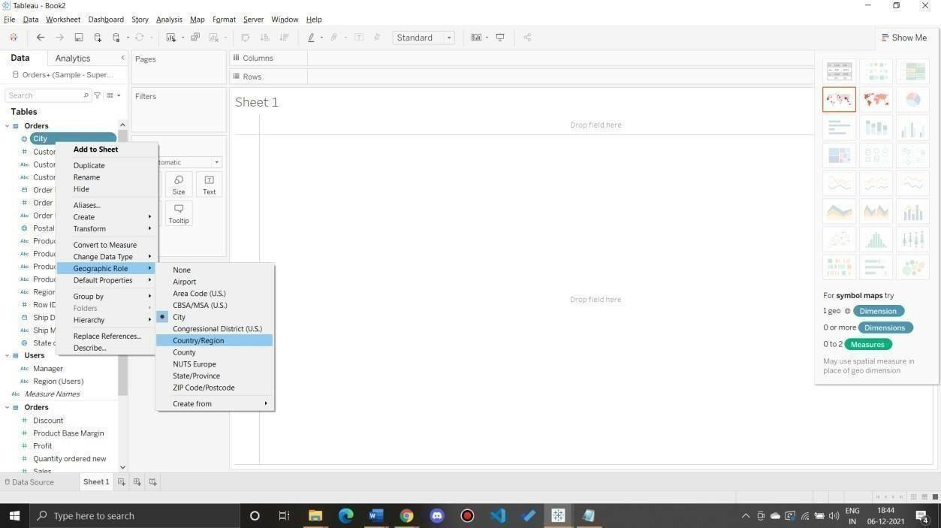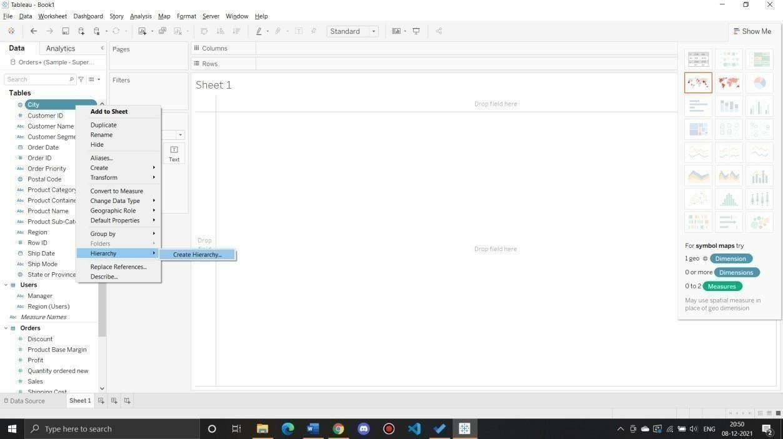

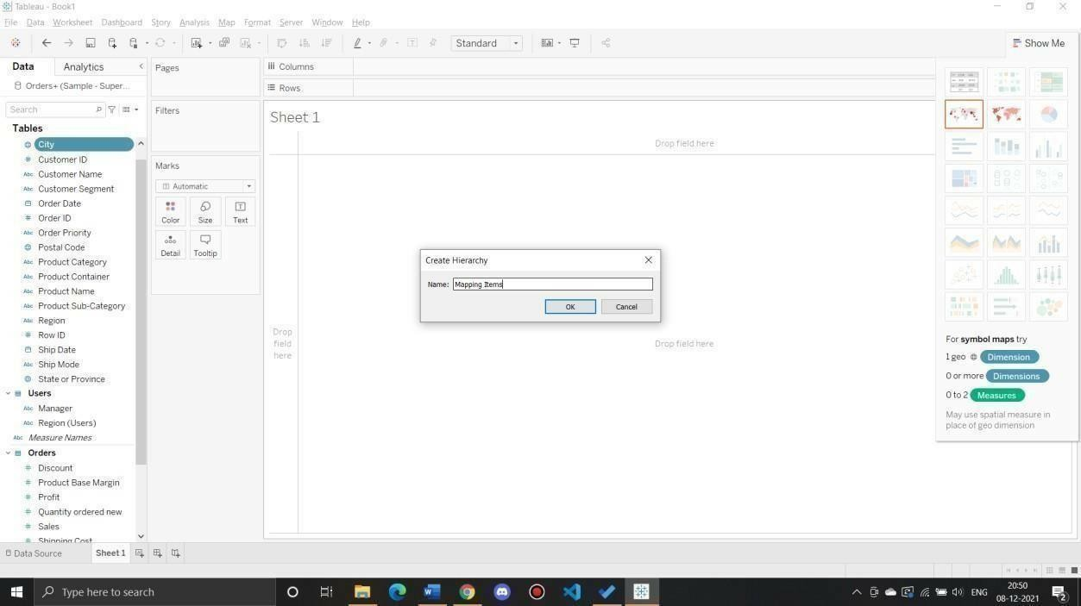

Build abasicmap

1) In the Data pane, double-click City**.

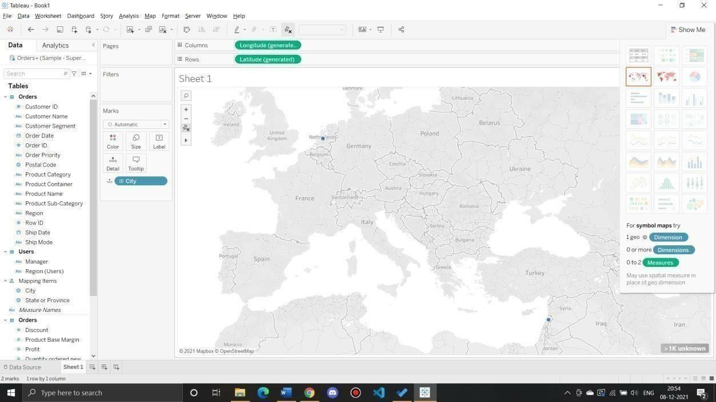

Add visual detailAdd color

From Measures, drag Sales to Color on the Marks card.

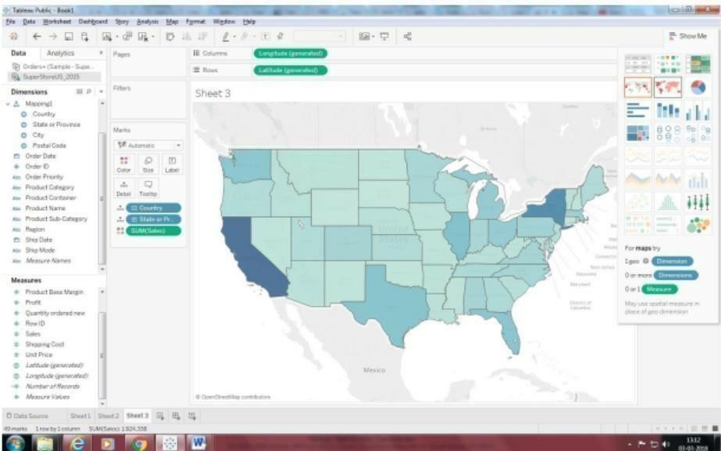

Add labels

From Measures, drag Sales to Label on the Marks card.

Each state is labeled with sum of sales. The numbers need a little bit of formatting, however. In the Data pane, right-click Sales and select Default Properties > Number Format.

In the Default Number Format dialog box that opens, select Number (Custom), and thendo the following: For Decimal Places, enter 0.

For Units, select Thousands (K). Click OK.

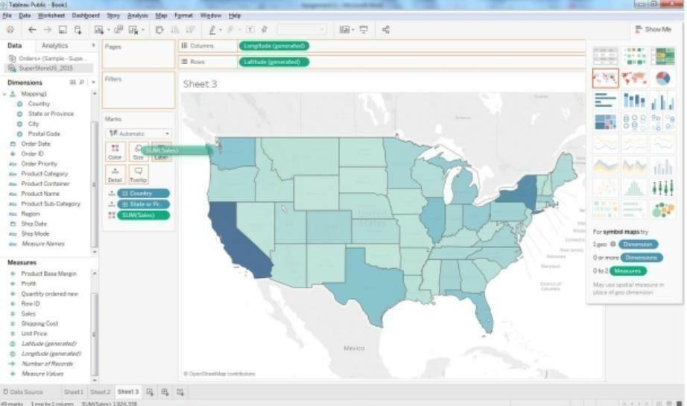

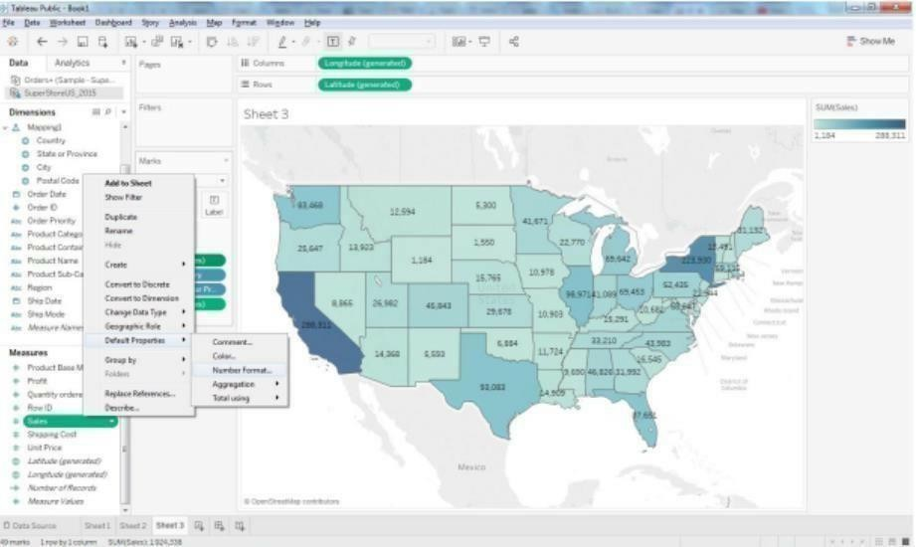

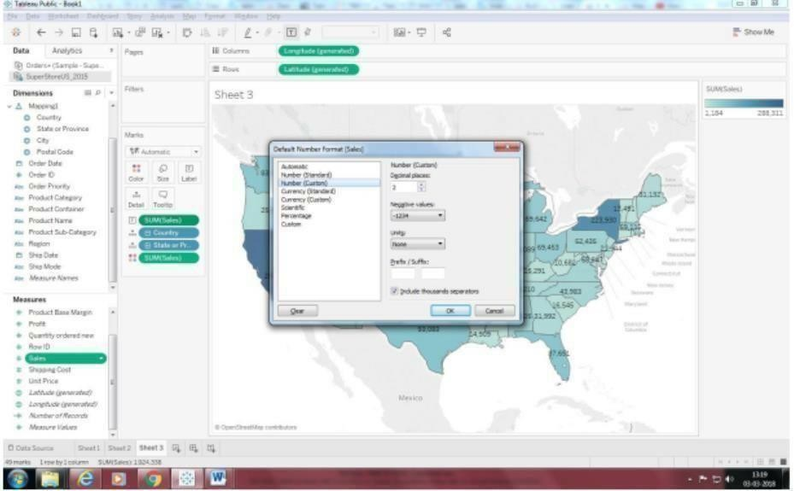

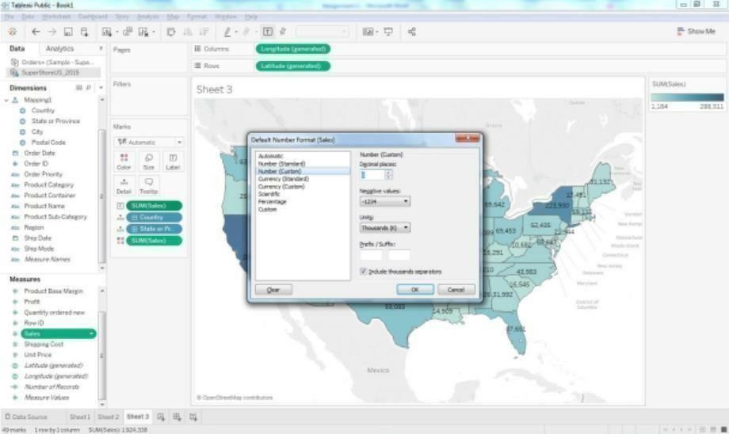

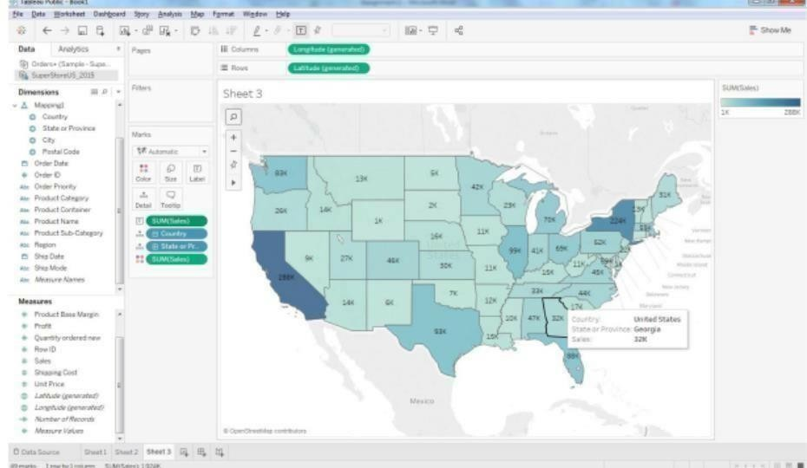

Q 2: Show Profit Ratio of each state as tooltip on map

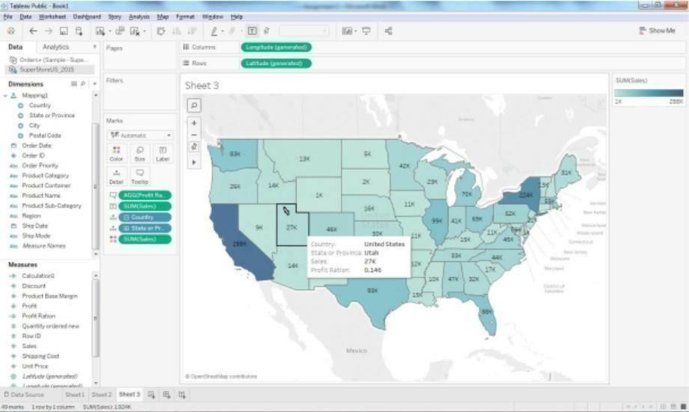

Q 3: Show Profit ratio for Grip Envelop products

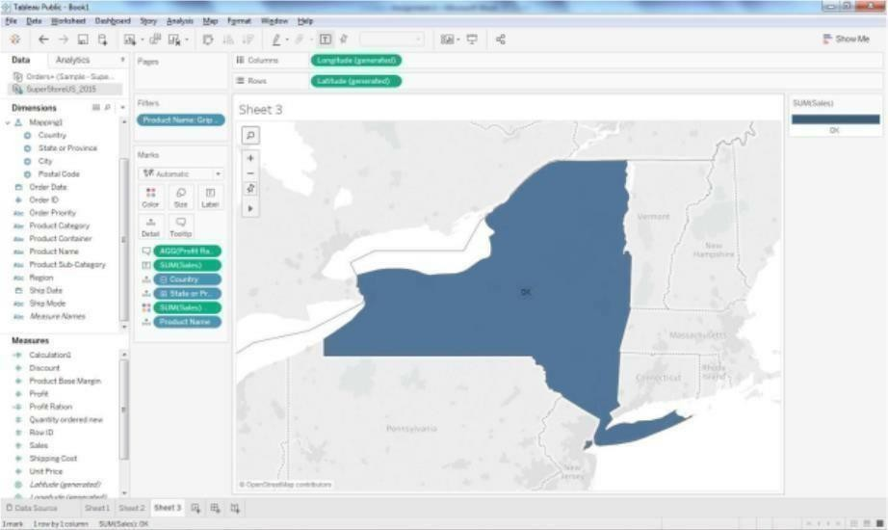

Q 4: In the technology product category which unprofitable state is surrounded by only profitable states.

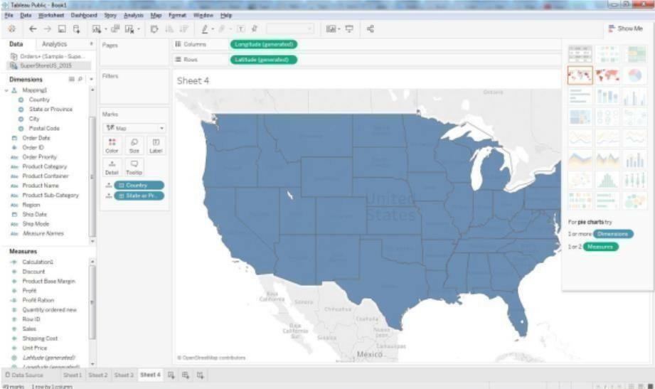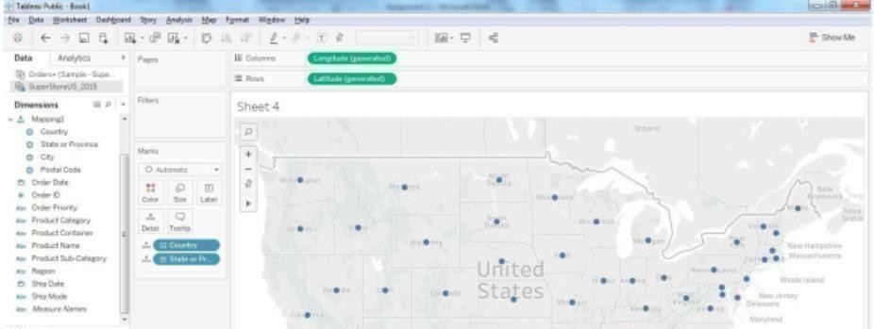

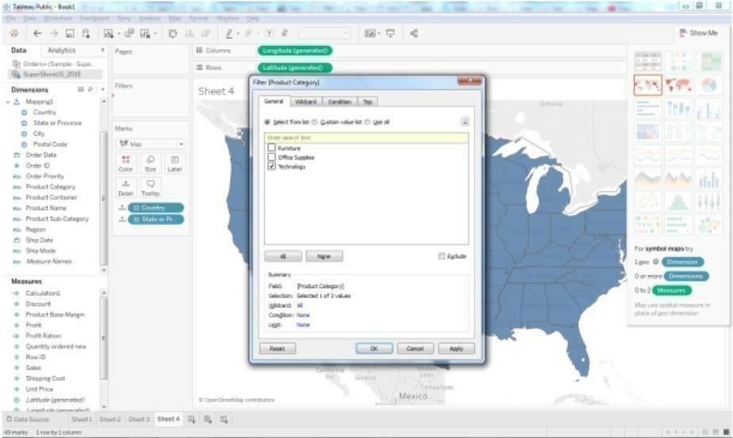Drag the product category on the filter shelf and

select in technology.

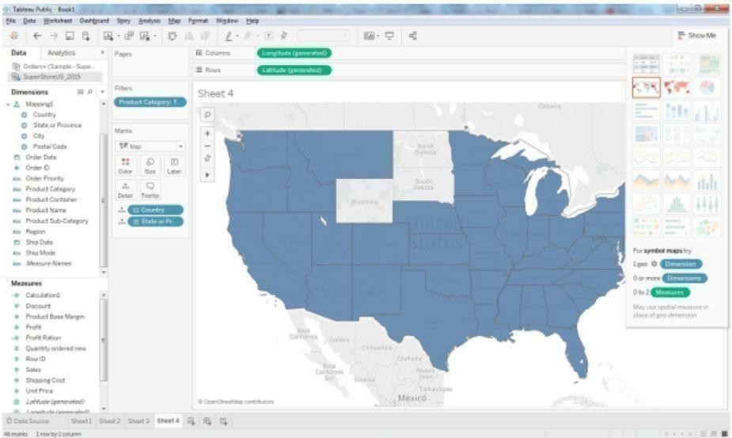

Now Drag the profit measure to color mark

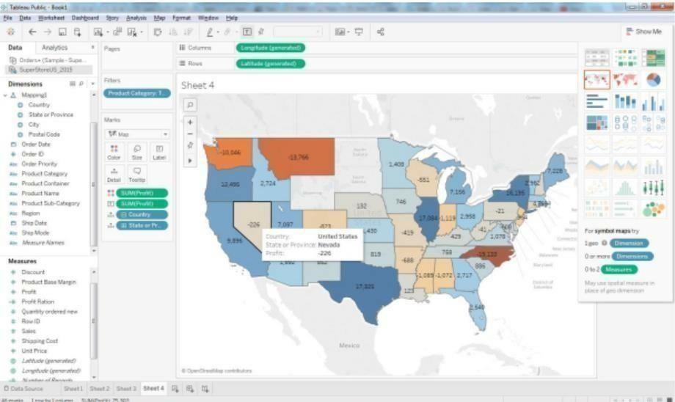

Add profit Label.

Now we can see Nevada State is surrounded by profitable states.

Q 5: Which state has the worst Gross Profit Ratio on Envelopes in the Corporate Customer Segmentthat were Shipped in 2015?

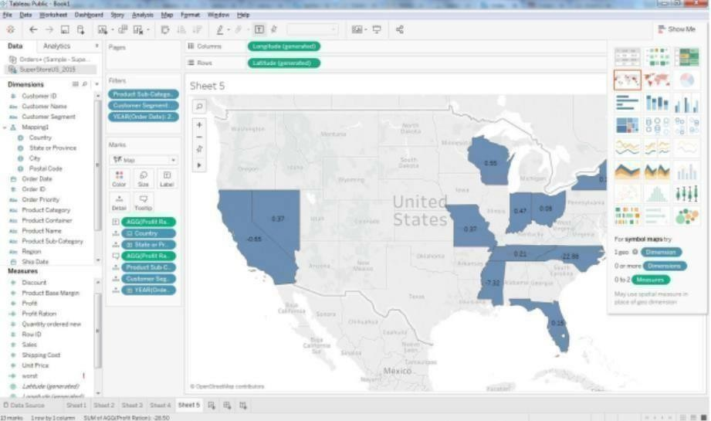

Preparing Reports

**Data Set**: Super store

Prapare a report showing product category wise sales

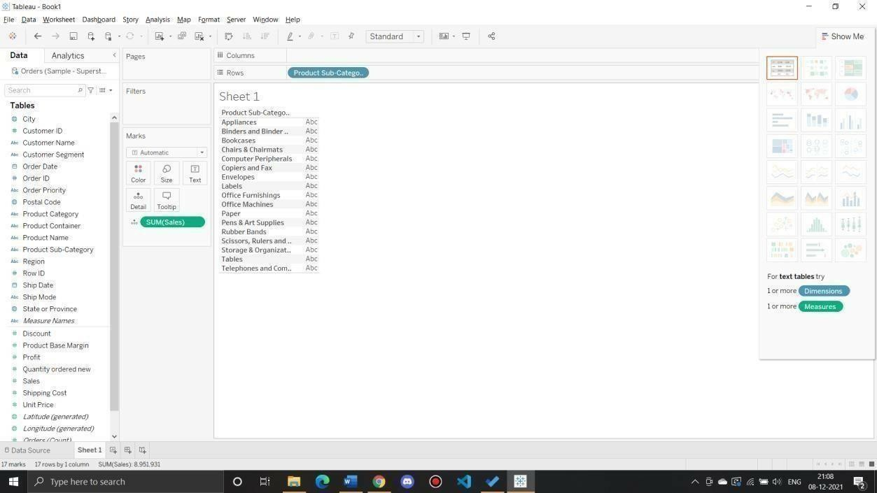

Report showing regionwise productwise sales

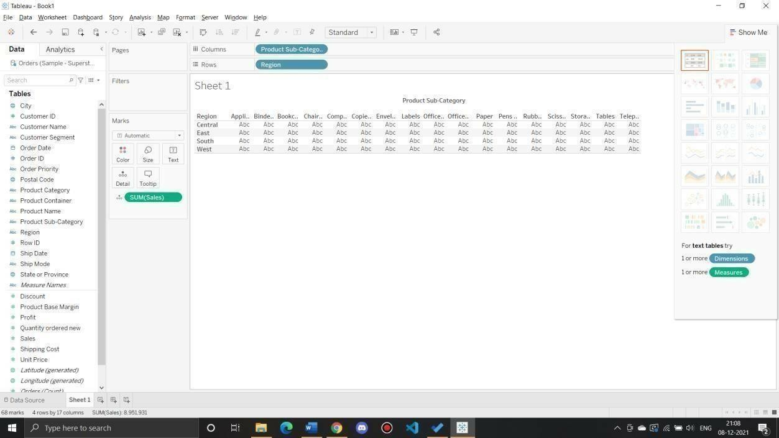

Report showing statewise sales

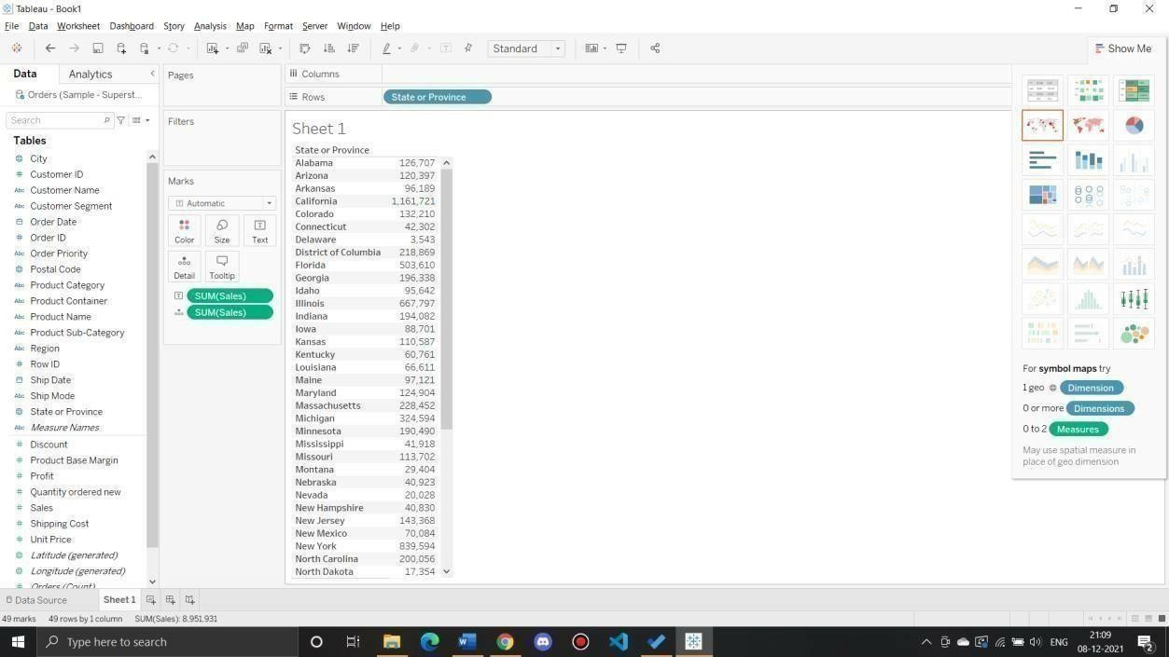

What is the percent of total Sales for the ‘Home Office’ Customer Segment in July of 2014?

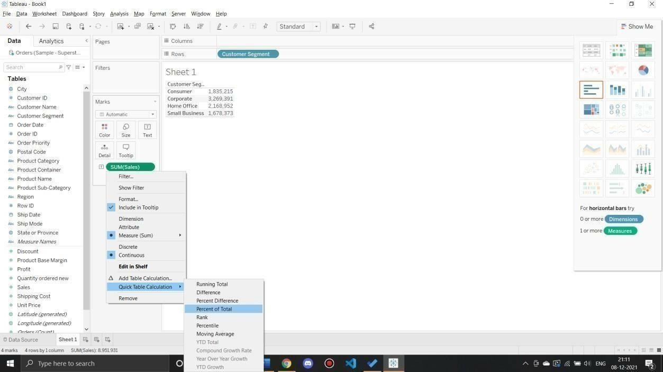

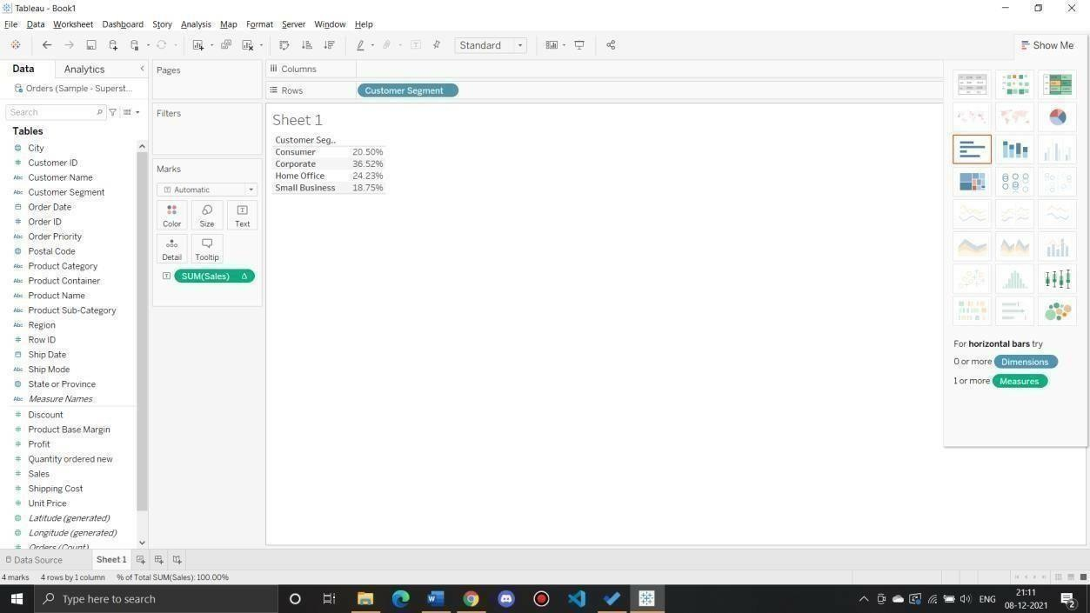

Findthetop 10 Product Names by Sales within each region. Whichproduct is ranked#2 in both the Central & West regions in 2015?

Drag “Product Name” dimension from data pane window to Row Shelf and then add an “order Date” on Filter shelf and select “Year” of Order date as 2015.After that put region on Filter shelf and select “Central” and “West” checkbox. Also, put a copy of region to the Column shelf as well.

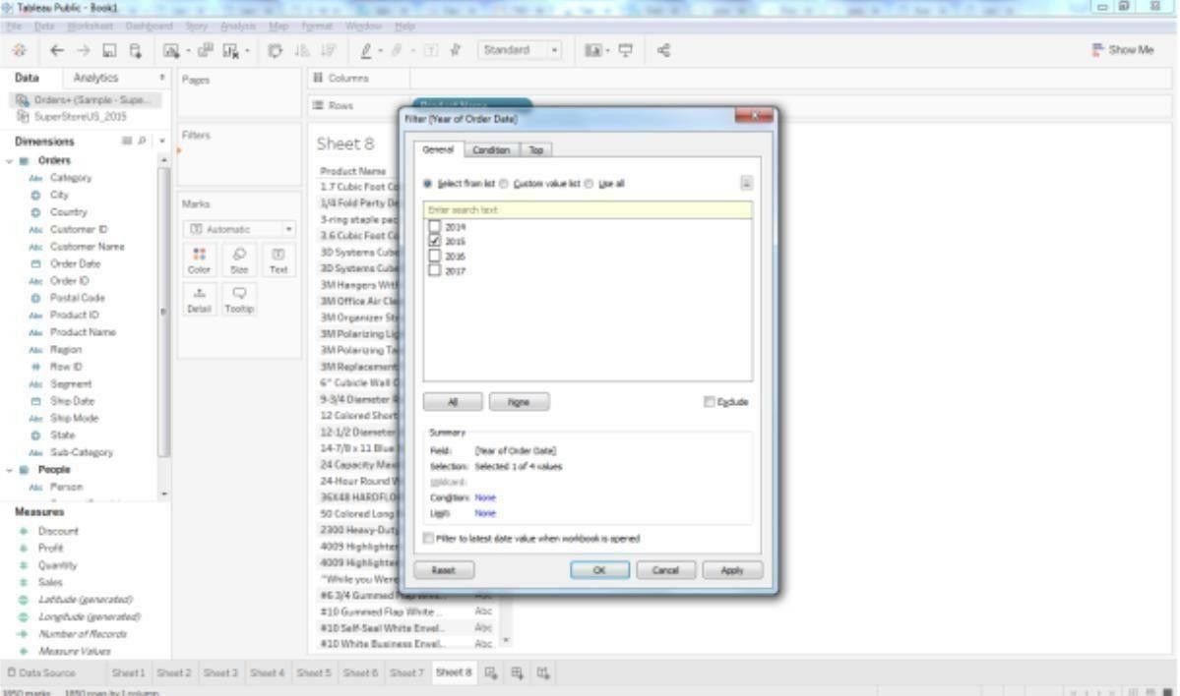

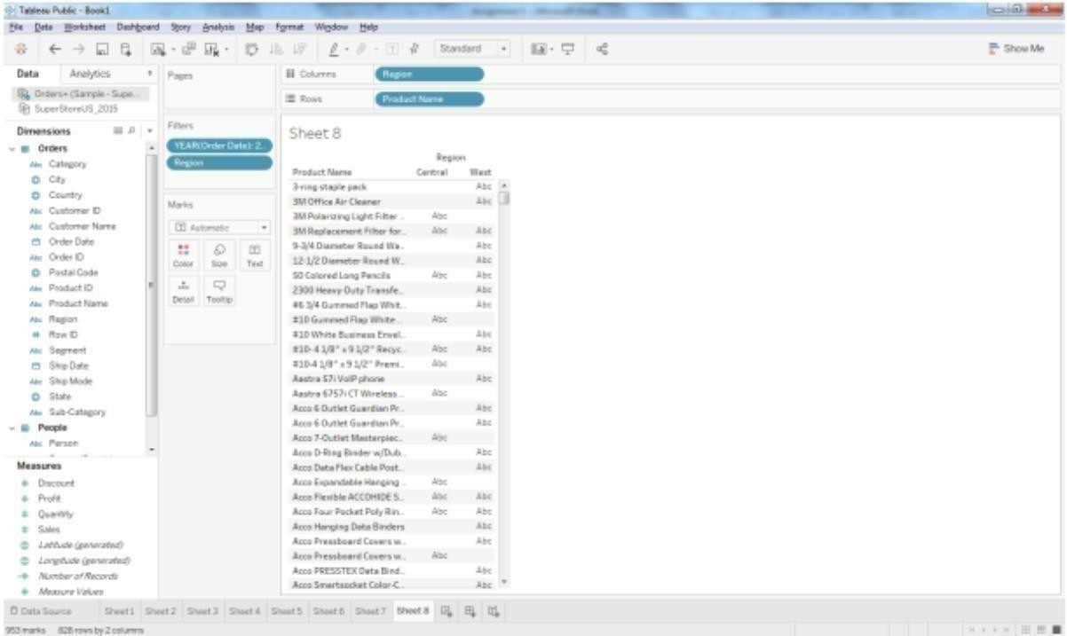

Drag a Sales measure to the text label. So for getting the Top 10 “product name” by sales, we need toadd the “Product name” on Filter shelf. Once the Filter Pop up is open, Select

“TOP” tab >By Field > Top 10 bySum (Sales).

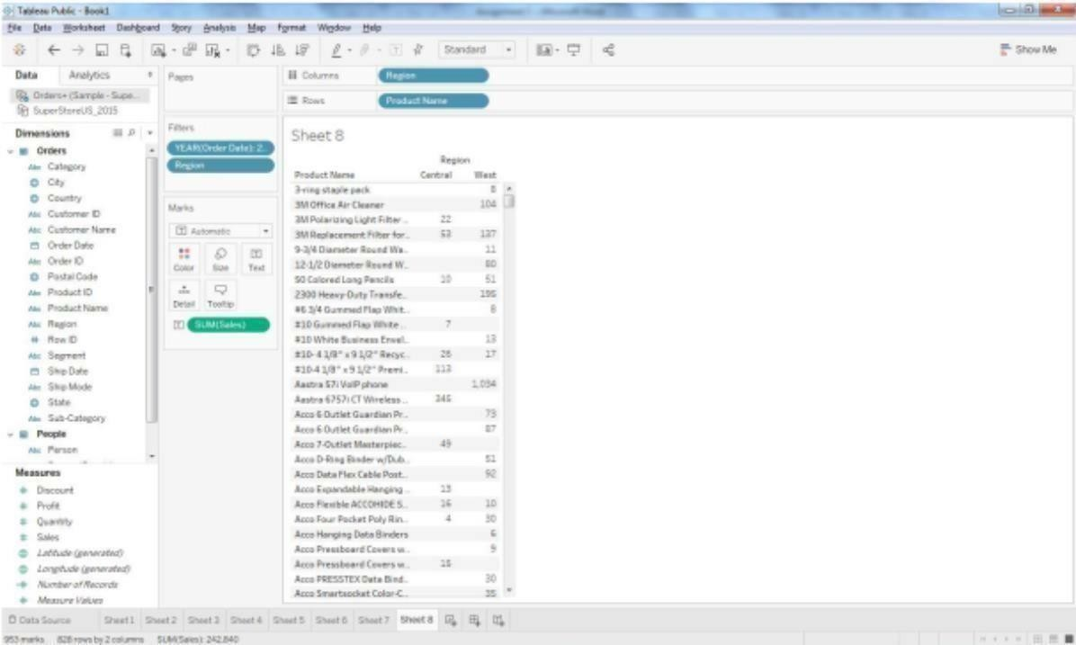

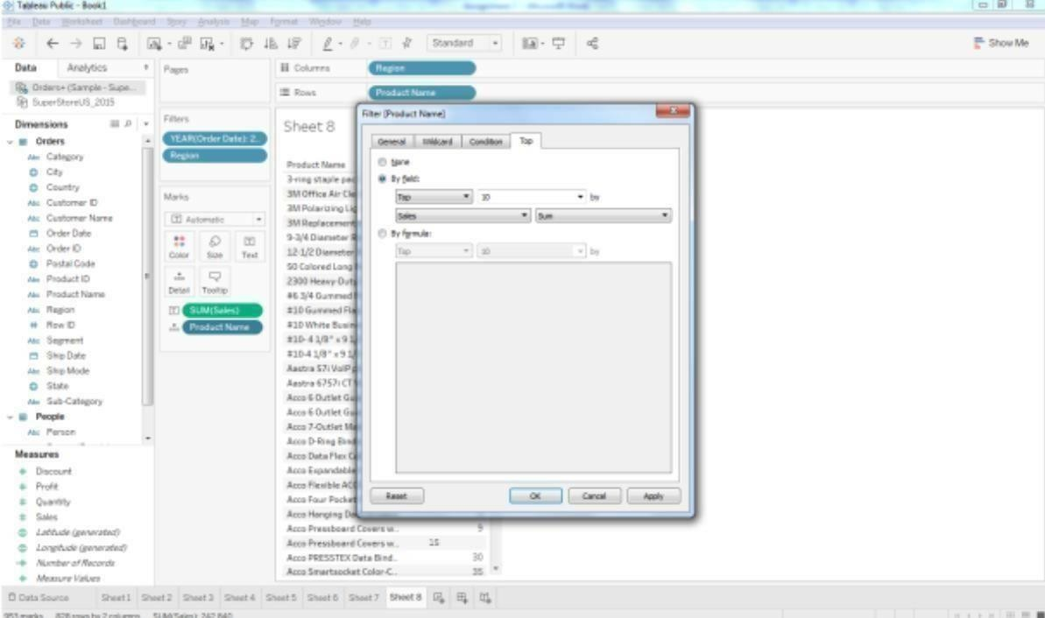

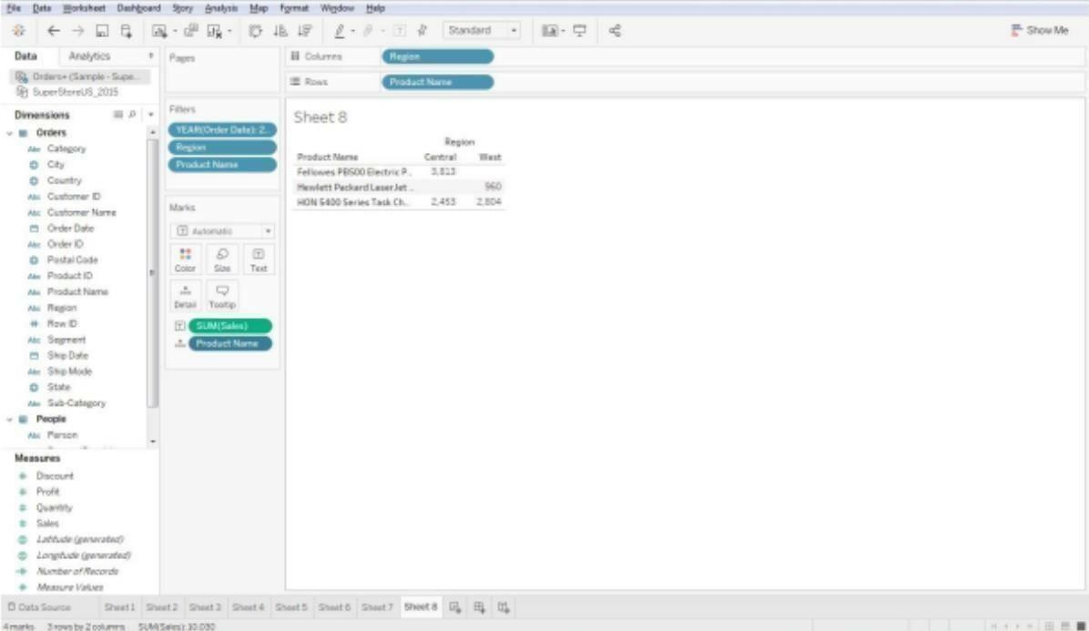

Right click on the aggregated Sales measure and click on arrow sign then select Quick Table Calculation

> Rank. As the default addressing is Table across, please change it into Table Down (Compute using

-> Table Down).

